**Guardian BeastDriver User Manual**

This driver is an extension of the ODrive platform, retaining the original control method and supporting compatible control of ODrive commands through a mapping mechanism. Through this manual, you can learn how to use odrivetool commands to control motors, how to operate using the graphical interface "Motor Wizard", and master the way to use ODrive commands under different protocols.

When using this manual, please make good use of the document search function (Ctrl+F)

1. **Preparatory Work**

Here we briefly introduce how to connect the motor using MotorGenius and odrivetool, as well as the installation of the software.

1.1 **Wiring Preparation**

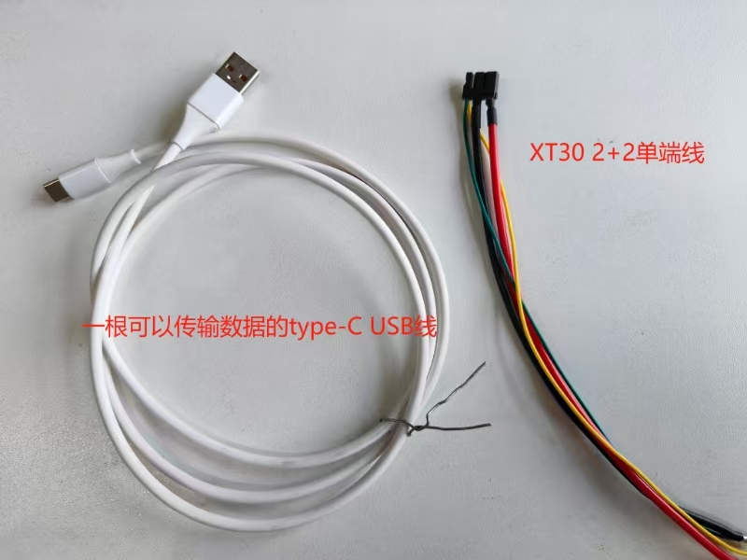

* Type-C USB Cable: **The USB cable cannot power the motor driver board**  and is only used for data transmission. Please note that some models do not support Type-C but use a customized 3PIN data cable. Please contact after-sales staff for instructions on how to connect.
* XT30 2+2 Power Cord: It is recommended to use a regulated power supply or battery to power the motor. The current of the power supply **must be at least greater than 5A**, and the voltage **should not be lower than 15V, with a maximum of 60V**. Note that when using a power supply of 24V or lower, remember to change the voltage lower limit to 10V or 8V in Motor Genius or odrivetool.

|  |
| --- |
| Python odrv0.config.dc_bus_undervoltage_trip_level = 10 |

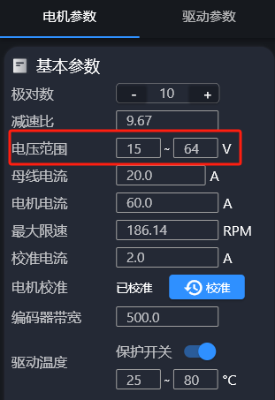

1.2 **USB Driver Installation**

**[zadig-2.9.exe]**

Visit the website <https://zadig.akeo.ie> and download the USB driver tool Zadig. Connect the drive to your computer using a Type-C data cable.  **Please power on the drive in advance, as USB cannot supply power to the drive.**  Open Zadig, click "Options", then click ""Motor" and select "CyberBeast Motor Driver Device (Interface 2)" from the drop-down box:

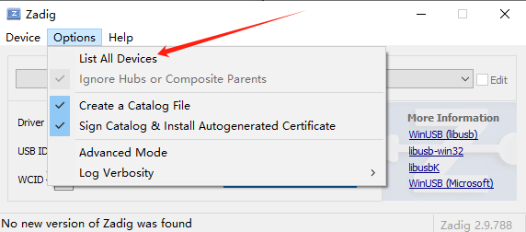

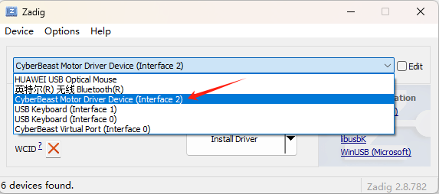

Select different USB drivers by clicking the up and down arrows. Please select the "libusb" driver version for this interface, and click "Install Driver" or "Replace Driver" to install the driver for this interface:

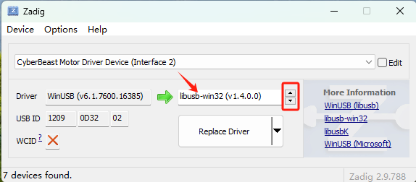

1.3 **Software Installation**

1.3.1 **Motor Sprite**

1. Install Visual C++ Build Tools

**[202506031149.mp4]**

Install Visual C++ Build Tools <https://visualstudio.microsoft.com/visual-cpp-build-tools/>, and during the installation process, check "Desktop development with C++", as shown in the figure below.

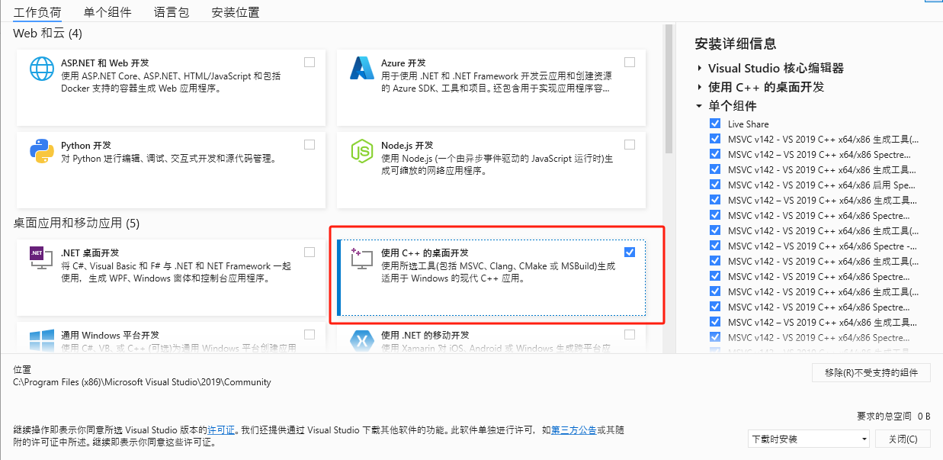

1. Install Motor Genius

Click to download:[Motor Genius Installation Package](https://bl.cyberbeast.cn/actuator/motorwizard.exe)

**[motorwizard.exe]**

Please download the Motor Genius installation package and install it in the following order

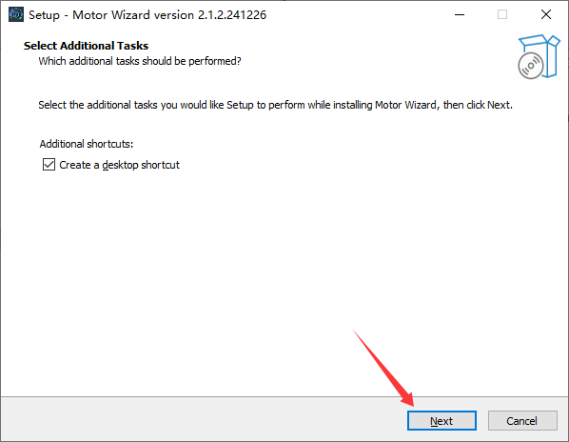

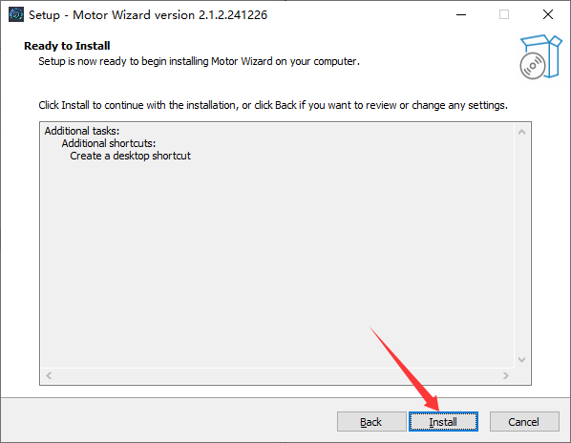

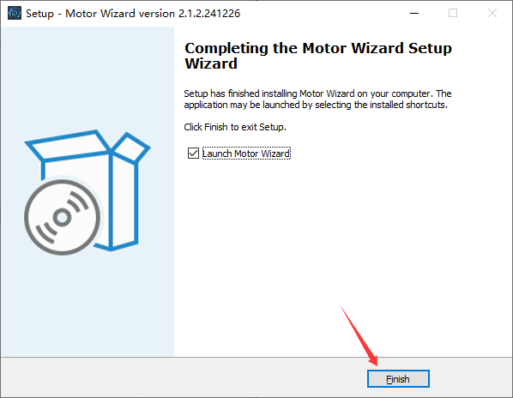

1.3.2 **odrivetool**

**Windows**

1. Install Python3

**[安装python正式.mp4]**

Go to the official Python website<https://www.python.org>to download the latest Python installer and follow the prompts to install it. Do not download the Python version from third-party websites or the Microsoft Store.**Please install Python with administrator privileges**.

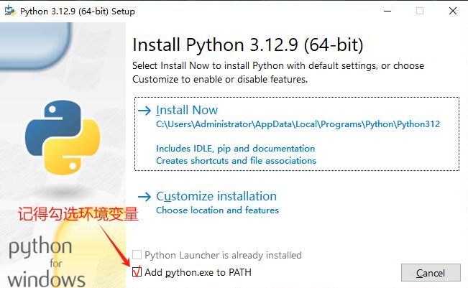

Here is a Python file that is not very new, provided for customers with slow download speeds to download:

**[python-3.12.9-amd64.exe]**

1. Install odrivetool and its related libraries

Open the end point, a page similar to the following figure, and then execute the subsequent instructions

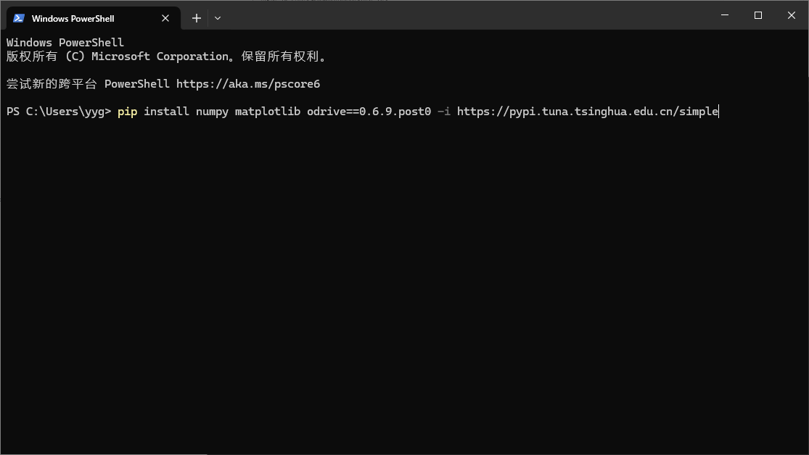

|  |
| --- |
| Python pip install numpy matplotlib odrive==0.6.9.post0 -i <https://pypi.tuna.tsinghua.edu.cn/simple> |

This instruction has been replaced with the installation using Tsinghua mirror source, so there is basically no need to worry about installation failures caused by slow network speed. Among them, numpy and matplotlib are optional and can be skipped. If an error occurs during the process, please retry. If the error persists, please restart your computer and then retry.

If you have completed the installation on Windows, please  [click](https://rcneo0sp7vgy.feishu.cn/docx/OBDNdrWanoj2JSxapQVcLF47nWc#doxcnMdEkk8IrBIIVRBmjuggr4e)  to jump to the next step.

|  |
| --- |
| If you see: "'python3' is not an internal or external command, nor a runnable program", it may be because Python has not been added to your PATH environment variables. Python comes with a small script that can fix this issue. Please navigate to the Python installation folder (usually C:\Program Files\Python<version number>\ or C:\Users<your username>\AppData\Local\Programs\Python\Python<version number>\ ), then double-click to run the "win_add2path.py" script. |

**Linux**

1. Install Python3

If python3 --version already returns a result similar to Python 3.8.0 or a later version, you can skip this step. The installation command depends on the Linux distribution you are using. For example, on Ubuntu:

|  |
| --- |
| Python sudo apt install python3 python3-pip |

If this command does not work, please check  [the official Python download website](https://www.python.org/downloads/) .

1. Install odrivetool and its related libraries

Among them, numpy and matplotlib are optional and do not need to be installed

|  |
| --- |
| Python pip3 install numpy matplotlib odrive==0.6.9.post0 -i <https://pypi.tuna.tsinghua.edu.cn/simple> |

1. Install USB Driver

|  |
| --- |
| Python sudo apt install libusb-1.0-0 |

If you have completed the installation on Linux, please  [click](https://rcneo0sp7vgy.feishu.cn/docx/OBDNdrWanoj2JSxapQVcLF47nWc#doxcnMdEkk8IrBIIVRBmjuggr4e)  to jump to the next step.

**WSL( Windows Subsystem for Linux)**

The first three steps are similar to those in Linux. Please refer to the previous subsection.

* Connect the drive to WSL

When you insert a Type-C data cable into Windows, by default, Windows will load the driver for this USB port, while WSL will not. To load this USB port into WSL, please refer to the Microsoft documentation (<https://learn.microsoft.com/zh-cn/windows/wsl/connect-usb>) for operation.

If you have completed the installation on WSL, please proceed to the next step: start odrivetool.

**Start odrivetool**

After the installation is completed according to your own system, open the terminal command-line shell (Windows PowerShell or Linux Terminal) and executeodrivetool(type odrivetool and press Enter). The following figure shows a successful connection under Windows:

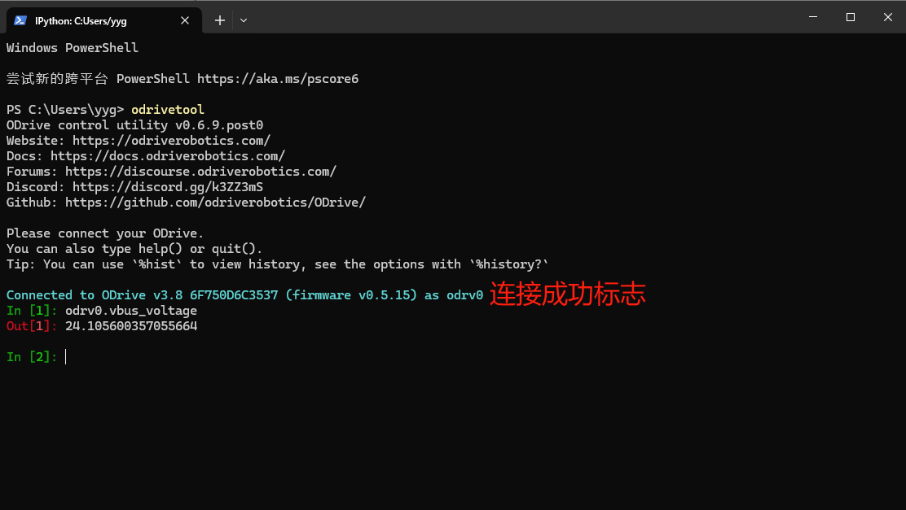

The instruction shown in the above figure is used to display the main power supply voltage of the main board.

The tool you are viewing is a fully functional Python command prompt, so you can enter any valid Python code.

2. **Motor Elf Usage**

Please first complete the installation of the USB driver and Motor Wizard according to  [1.2](https://rcneo0sp7vgy.feishu.cn/docx/OBDNdrWanoj2JSxapQVcLF47nWc#doxcnjesLQXyg3tnBpI6r0Fiz4d)  and  [1.3.1](https://rcneo0sp7vgy.feishu.cn/docx/OBDNdrWanoj2JSxapQVcLF47nWc#doxcnbSwonrwUXgpVMf23UfXr5d) , and then proceed to read this section.

2.1 **Interface Introduction**

|  |  |
| --- | --- |
|  |  |

1. Real-time waveform monitoring

Multiple real-time data waveform graphs are displayed at the top of the interface, including:

* **Three-phase current waveforms** (IA, IB, IC): Reflect the actual currents in the three-phase windings of the motor.
* **DQ Axis Currents** (IQ, ID, and their reference values IqRef, IdRef): Show the comparison between the actual current and the target current of the motor under current loop control.
* **Speed Curve** (SPD, SPDref): Comparison between real-time speed and target speed, which helps to observe the performance of the speed loop.
* **Position Curve** (EA, MA): Reflects the actual position and target position, facilitating the debugging of the position loop.

1. Central Instrument Panel

* **Motor speed and torque display**: The center dashboard displays the current speed (RPM) and motor output torque (Nm).
* **Angle Indication** : Displays the angle information of the current position of the motor.
* **One-touch Start Button**: Click the central "Start Motor" button to quickly start or stop the motor operation.
* **Motor Operating Status**: The left side displays the current operating mode of the motor (e.g., "Idle" state).
* **Power Monitoring**: The right side displays the current motor power and bus voltage.

1. Parameter Configuration Area

Multiple buttons are provided at the bottom of the interface, each leading to a different parameter configuration page:

* **Motor Parameters**: Set and view basic parameters related to the motor.
* **Drive Parameters**: Configure the control parameters of the motor drive, such as current loop/speed loop PI parameters, etc.
* **ODrive Parameters**: Internal parameter management and debugging for the ODrive architecture.
* **Debug Log**: Used to view detailed log output during the debugging process, facilitating problem location.

Next, I will introduce in detail what each of the four middle icons shows after being clicked

2.1.1 **Share, Sync, and Upgrade**

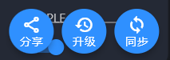

Click on the motor parameters and we can see three buttons

* Share

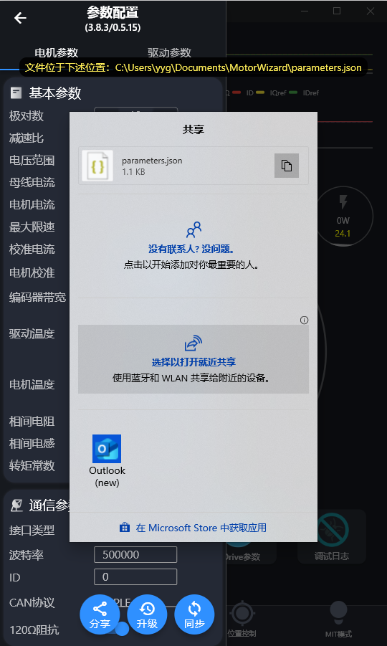

After clicking on the share button, we can download the JSON file of the motor parameters. Currently, the Motor Wizard does not support parameter import. The obtained JSON file can be downloaded to other motors via odrivetool (see details in  [Backup and Restore Parameters](https://rcneo0sp7vgy.feishu.cn/docx/OBDNdrWanoj2JSxapQVcLF47nWc#doxcnNbuq3Omll5eQF7SZyj9gSc)  )

* Upgrade

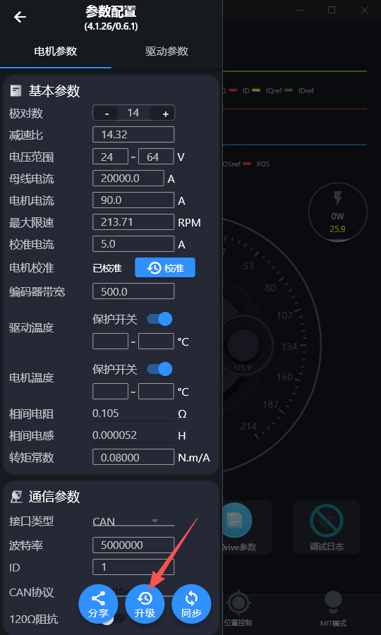

After clicking Upgrade, the motor will enter the upgrade mode (equivalent to executing odrv0.enter_dfu_mode () in odrivetool), the Motor Genius will disconnect from the motor, and the motor firmware can be flashed (see  [Firmware Upgrade](https://rcneo0sp7vgy.feishu.cn/docx/OBDNdrWanoj2JSxapQVcLF47nWc#doxcnV4tnHoxU0WXCDI9mqZ7Wjg)  for details).

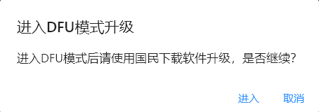

* Synchronize

After each parameter change, you need to click "Sync" in the idle state to save the written parameters, which will not be lost when power is cut off. After synchronization, the motor will restart, and then you need to wait a few seconds for the motor to reconnect (odrv0.save_configuration()).

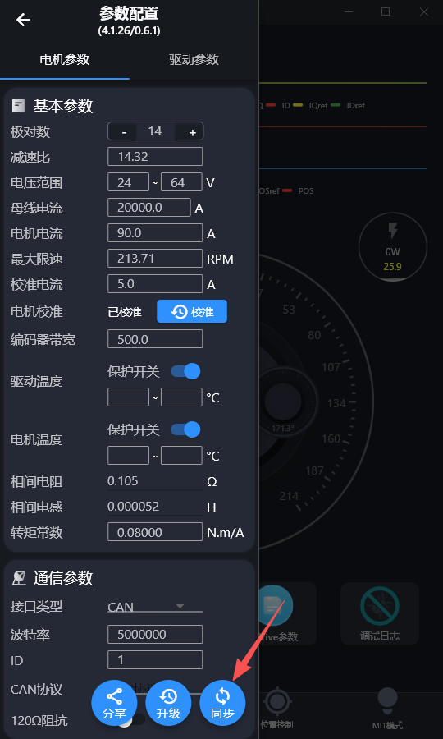

Long-pressing the synchronization button will erase all configured parameters and restore the default parameters (odrv0.erase_configuration()).

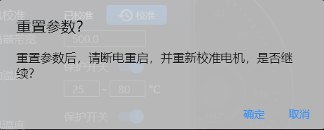

2.1.2 **Motor Parameters**

By clicking on the motor parameter icon in the above figure, we can see the following parameters

|  |
| --- |
| * After all parameter configurations on this page have been changed, you need to click "Synchronize" to save the parameters while the motor is in an idle state * The line of text below the parameter configuration is the hardware version/firmware version number. The hardware version refers to the version number of the self-driving board, and the firmware version refers to the version number of the driver firmware used by the current driver (firmware upgrades may result in different firmware version numbers). As shown in the figure, the hardware version is 3.8.3, and the firmware version is 0.5.15 |

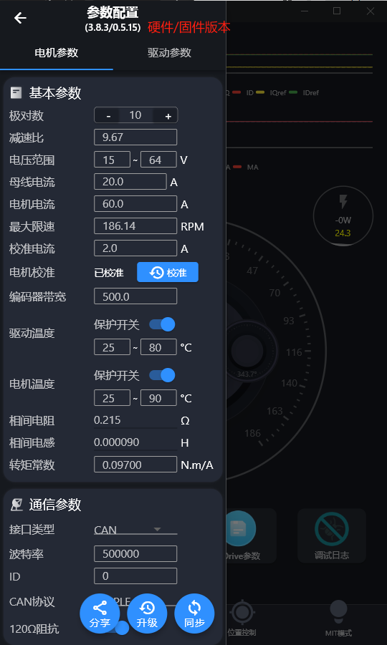

Corresponding to the introduction of each parameter, the odrivetool command is as follows:

***Basic Parameters***

|  |  |  |  |
| --- | --- | --- | --- |
| **Parameter Name** | **Description** | **Example value** | **odrivetool corresponding field** |
| Number of pole pairs | Number of pole pairs of the motor (poles / 2) | 10 | odrv0.axis0.motor.config.pole_pairs |
| Reduction ratio | Reduction ratio between the motor output shaft and the encoder | 9.67 | odrv0.axis0.motor.config.gear_ratio |
| Bus voltage range | Acceptable bus input voltage range | 15 V ~ 64 V | odrv0.config.dc_bus_undervoltage_trip_level  odrv0.config.dc_bus_overvoltage_trip_level |
| Bus Current | Maximum allowable supply current of the power supply | 20.0 A | odrv0.config.dc_max_positive_current |
| Reverse bus current | Maximum allowable reverse charging current (negative) of the power supply | -50.0 A | odrv0.config.dc_max_negative_current |
| Motor Current | Maximum allowable current of the motor | 60.0 A | odrv0.axis0.motor.config.current_lim |
| Motor Speed | Maximum Motor Speed (RPM) | 186.14 RPM (Output Shaft) | odrv0.axis0.controller.config.vel_limit (unit in odrivetool is revolutions per second on the rotor side) |
| Calibration Current | Current injected during motor calibration | 2.0 A | odrv0.axis0.motor.config.calibration_current |
| Motor Calibration | One-key motor calibration operation button | - | odrv0.axis0.requested_state = AXIS_STATE_FULL_CALIBRATION_SEQUENCE |
| Encoder Bandwidth | Encoder Filter Bandwidth Setting | 500 | odrv0.axis0.encoder.config.bandwidth |
| Drive Temperature Protection | Drive Temperature Protection Threshold | 25 ~ 80°C | odrv0.axis0.motor.fet_thermistor.config.enabled = True  odrv0.axis0.motor.fet_thermistor.config.temp_limit_lower  odrv0.axis0.motor.fet_thermistor.config.temp_limit_upper |
| Motor Temperature Protection | Motor Temperature Protection Threshold | 25 ~ 90°C | odrv0.axis0.motor.motor_thermistor.config.enabled = True  odrv0.axis0.motor.motor_thermistor.config.temp_limit_lower  odrv0.axis0.motor.motor_thermistor.config.temp_limit_upper |
| Interphase resistance | Motor phase resistance | 0.215 Ω | odrv0.axis0.motor.config.phase_resistance |
| Interphase Inductance | Motor phase inductance | 0.000090 H | odrv0.axis0.motor.config.phase_inductance |
| Torque Constant | Current torque conversion coefficient (rotor side) | 0.09700 Nm/A | odrv0.axis0.motor.config.torque_constant |

Communication parameters will be described in the usage section (5.1 5.2) of each protocol, explaining how to configure this part

2.1.3 **Drive Parameters**

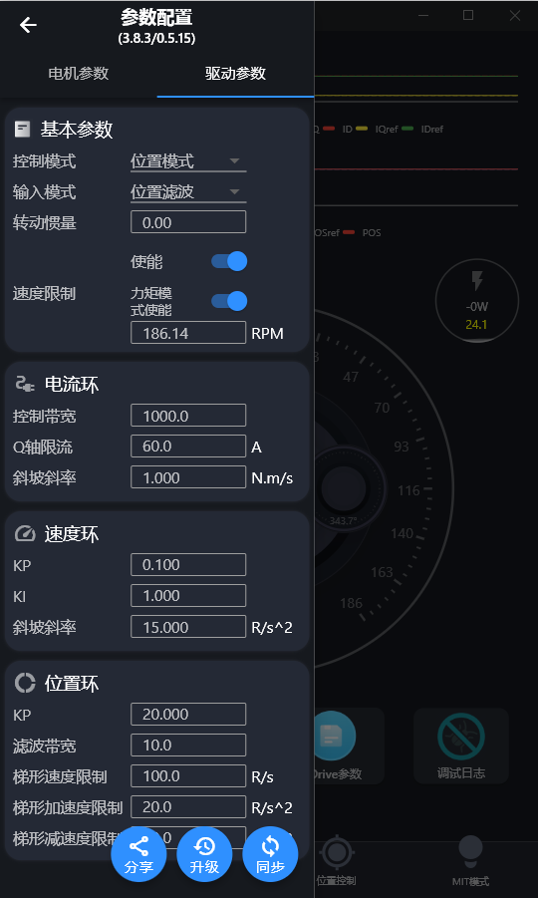

Parameter introduction and corresponding odrivetool commands are as follows:

***Basic Parameters (Control Mode Configuration)***

|  |  |  |  |
| --- | --- | --- | --- |
| Parameter Name | Description | Example value | odrivetool corresponding field |
| Control Mode | Motor control types: position/speed/current, etc. | Position Mode | odrv0.axis0.controller.config.control_mode |
| Input Mode | Input instruction types: position filtering, step/direction, analog, etc. | Position Filtering | odrv0.axis0.controller.config.input_mode |
| Moment of Inertia | Inertia of the rotating part of the motor (required for torque mode) | 0.00 | odrv0.axis0.controller.config.inertia |
| Speed Limit | Is speed limit enabled? | Enable | odrv0.axis0.controller.config.enable_vel_limit |
| Torque Chain Locking | Is speed limited when torque control is enabled? | Enable | odrv0.axis0.controller.config.enable_torque_mode_vel_limit |
| Maximum Speed | Maximum operating speed | 186.14 RPM  (Output Shaft) | odrv0.axis0.controller.config.vel_limit (unit in odrivetool is revolutions per second on the rotor side) |

***Current Loop***

|  |  |  |  |
| --- | --- | --- | --- |
| Parameter Name | Description | Example value | odrivetool corresponding field |
| Control bandwidth | The bandwidth of the current loop, the higher the faster, but may oscillate | 1000.0 | odrv0.axis0.motor.config.current_control_bandwidth |
| Q-axis limit viewership of | Motor maximum Q-axis current | 60.0 A | odrv0.axis0.motor.config.current_lim |
| Slope Gradient | Current Rate of Change Limit | 1.000 N·m/s | odrv0.axis0.controller.config.torque_ramp_rate |

***Speed Loop***

|  |  |  |  |
| --- | --- | --- | --- |
| Parameter Name | Description | Example value | odrivetool corresponding field |
| KP | Proportional coefficient | 0.100 | odrv0.axis0.controller.config.vel_gain |
| KI | Integral coefficient | 1.000 | odrv0.axis0.controller.config.vel_integrator_gain |
| Slope Gradient | **In speed ramp mode** , speed change limit, acceleration | 15.000 R/s² | odrv0.axis0.controller.config.vel_ramp_rate |

***Position Loop***

|  |  |  |  |
| --- | --- | --- | --- |
| Parameter Name | Description | Example value | odrivetool corresponding field |
| KP | Proportional gain (for position error) | 20.000 | odrv0.axis0.controller.config.pos_gain |
| Filter Bandwidth | Bandwidth for filtering jitter of position signals | 10.0 | odrv0.axis0.controller.config.input_filter_bandwidth |
| Trapezoidal speed limit | **In the position trapezoidal curve mode** , the maximum target speed (position input) | 100.0 R/s | odrv0.axis0.trap_traj.config.vel_limit |
| Trapezoidal acceleration limit | **In the position trapezoidal curve mode** , the maximum target acceleration | 20.0 R/s² | odrv0.axis0.trap_traj.config.accel_limit |
| Trapezoidal Deceleration Limit | **In the position trapezoidal curve mode** , the maximum target deceleration | 20.0 R/s² | odrv0.axis0.trap_traj.config.decel_limit |

2.1.4 **ODrive Parameters**

The Motor Wizard displays some of the most basic configurable parameters of the motor, while odrivetool has many parameters that are not shown in the Motor Wizard. We can find and input the odrivetool commands in the ODrive Parameters function item, and all the commands that can be entered in odrivetool can be found here.

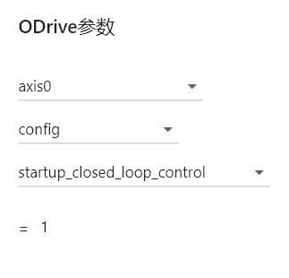

For example, we can configure the motor here to enter the closed-loop operating mode upon startup (as shown in the figure above).

|  |
| --- |
| Note that after configuring the parameters on this page, if you need to power off and retain the parameters, you need to click Motor Parameters -> Synchronize to save the parameters while the motor is in the**idle state**. Simply put,**press Enter after input and then click Synchronize**. |

2.2 **Four modes of control**

Text description to be updated. For details on descriptions of different modes, see [3.3](https://rcneo0sp7vgy.feishu.cn/docx/OBDNdrWanoj2JSxapQVcLF47nWc#doxcnCepYn3Aupbpafr5y9aJUTc). For details on mode parameter adjustment, see [4.2](https://rcneo0sp7vgy.feishu.cn/docx/OBDNdrWanoj2JSxapQVcLF47nWc#doxcnGRteThtk7BjVXmcQ4dW6Xg)

2.2.1 **MIT Model**

|  |
| --- |
| Before using this mode, please ensure that the motor's torque constant ( odrv0.axis0.motor.config.torque_constant) is set correctly; otherwise, the output torque may not meet expectations. You can consult the manufacturer to inquire about the correct torque constant. |

With the motor already calibrated, switch the dial to MIT mode, click to start the motor, then right-click on the dial, and you can see the parameters that can be entered (as shown in the figure below, from left to right). Next, we will introduce how to set the parameters in different usage modes.

|  |  |  |
| --- | --- | --- |
|  |  |  |

* Position control mode

In position control mode, the motor output shaft will be positioned and maintained at the set target angle. For example, if the motor output shaft needs to be stabilized at a position of 60°, the following motion parameters can be set: target position 60°, KP 50, KD 1, and the remaining parameters (speed feedforward and torque feedforward) set to 0:

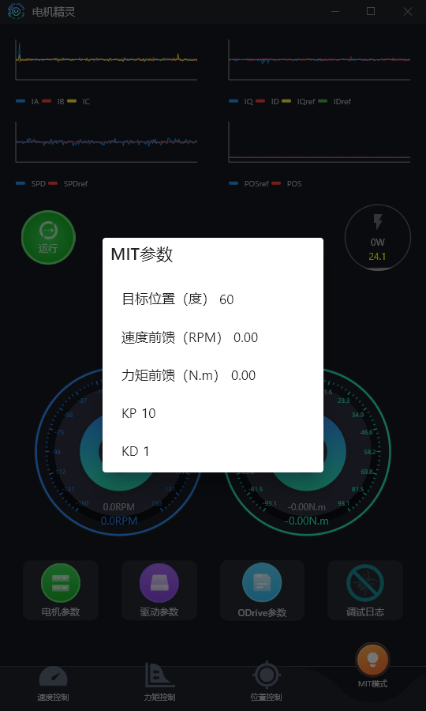

* Speed control mode

In speed control mode, the goal is for the motor output shaft to operate at the given desired speed. For example, if the motor output shaft speed needs to be 100 RPM, the following motion parameters can be set: speed feedforward 100 RPM, KD 1.5, and the remaining parameters (target position, speed feedforward, torque feedforward, and KP) set to 0:

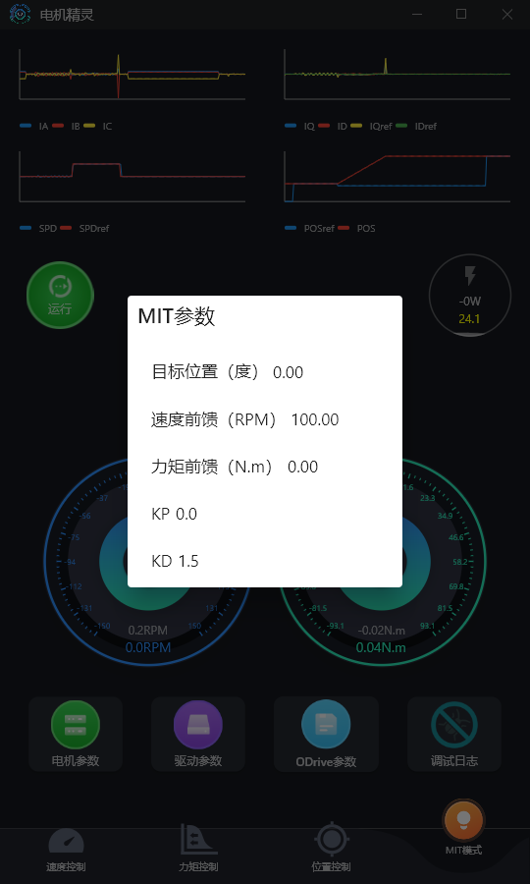

* Torque Control Mode

In torque control mode, the goal is for the motor output shaft to operate at the given desired torque. For example, if the desired motor output torque is 1 Nm, the following motion parameters can be set: torque feedforward is set to 1 Nm, and the remaining parameters (target position, velocity feedforward, torque feedforward, KP, and KD) are set to 0:

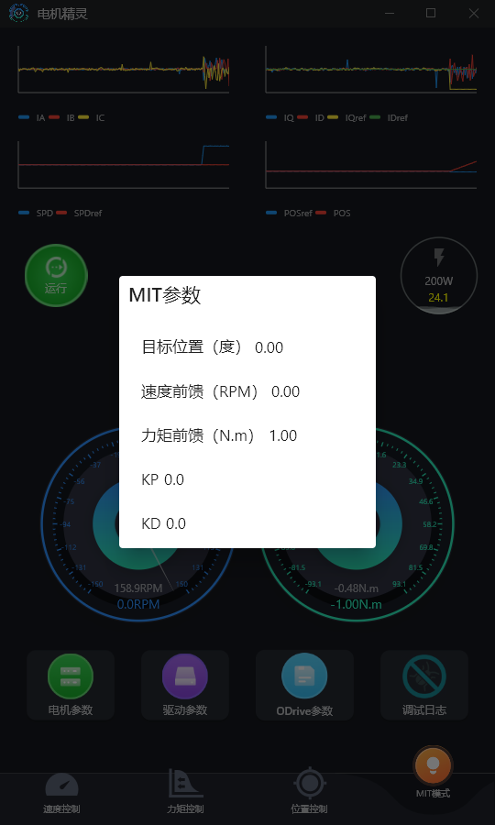

* Damping Mode

Damping mode is commonly used to achieve motor deceleration, braking, or resistance control. In this mode, the motor applies resistance or braking force to external motion by outputting appropriate torque, thereby achieving the effect of decelerating or suppressing motion. Users can flexibly control the magnitude of the damping force or braking force by adjusting the output parameters to meet different deceleration or braking requirements. For example, when setting the parameters, set the damping coefficient KD to a non-zero value (e.g., KD = 2), and set all other parameters to 0.

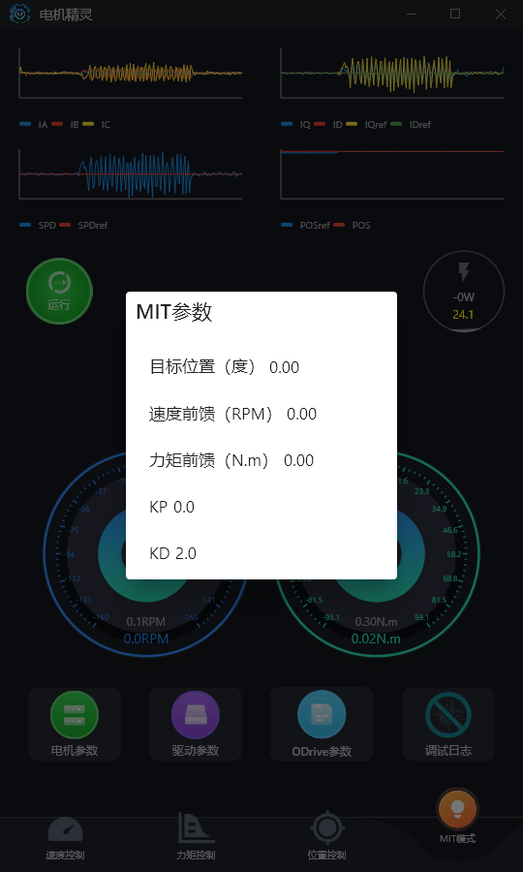

After sending the parameters, the motor will not rotate actively, but when an external force drives the motor to rotate, the motor will generate an impedance torque opposite to the direction of rotation. The magnitude of this torque is proportional to the rotational speed: the higher the rotational speed, the greater the impedance torque.

* Zero Torque Mode

The zero-torque mode is designed to keep the output torque of the motor at zero or close to zero. In this mode, the motor does not completely stop running but actively outputs torque to counteract its own frictional torque, thereby achieving an approximately "zero-resistance" effect. When setting, all motion parameters are set to 0. After sending the parameters, the motor will not actively rotate, but if you try to manually rotate the output shaft, you can feel that its rotational resistance is significantly lower than the mechanical resistance when the motor is not powered.

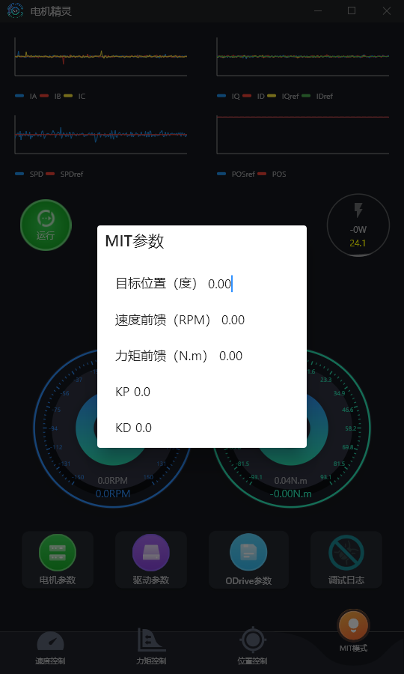

* Force-Position Hybrid Control Mode

When applied to some robots, the upper-level controller sends the desired angle, desired velocity, and torque feedforward to the joint motors simultaneously. This is force-position hybrid control. For example, if the target position is set to 180°, the velocity to 0, the feedforward torque to 0.5 Nm, KP to 15, and KD to 2, this is force-position hybrid control.

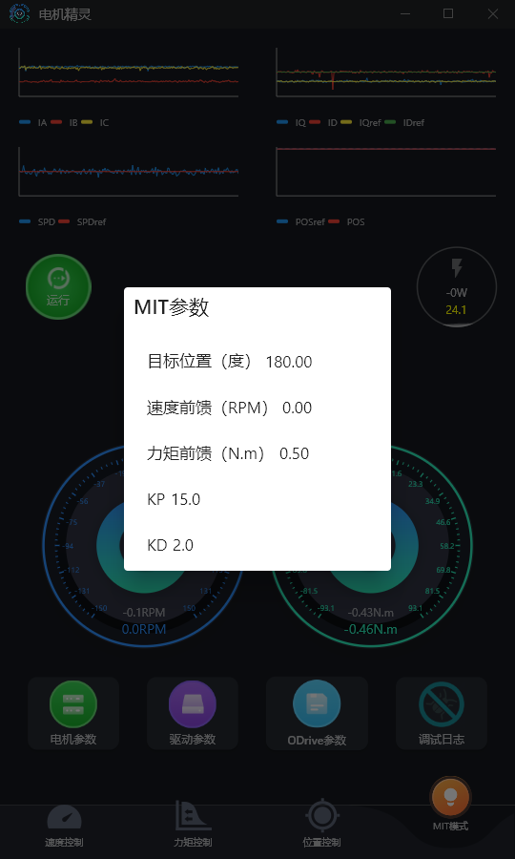

2.3 **View error code**

When our motor triggers an alarm, the motor will immediately stop running and enter the idle state. As shown in the figure below, we need to right-click on the red anomaly to obtain the anomaly code.

|  |  |
| --- | --- |
|  |  |

System Fault, Axis Fault, Motor Fault, Encoder Fault, Controller Fault

can correspond to  [the exception codes in the protocol manual](https://cyberbeast.feishu.cn/docx/BPnQd8reEotLWVxqHFNc9qYZnKh#KKr4dVPH3oQ9r5x5KxocJLmQn4b)  to check the specific exceptions corresponding to each exception code. Multiple exceptions may occur simultaneously, among which there will be the most fundamental one.

Taking the above figure as an example, convert it to hexadecimal

System Fault: 0x00000002

Axis Fault: 0x00000040

Motor Fault: 0x01000000

Encoder Fault: 0

Controller Fault: 0

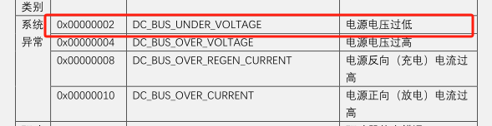

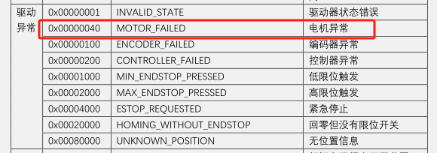

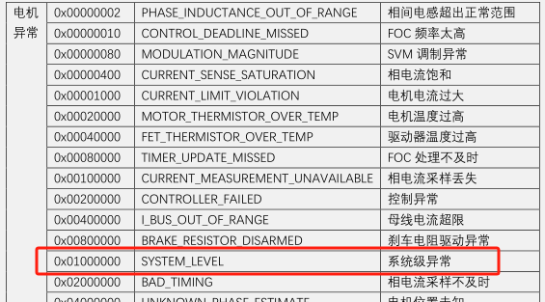

3. **Odrivetool Usage**

|  |
| --- |
| Operation Instructions   * Frequently using the TAB key will provide command suggestions, similar to the command suggestions in Linux, and you can use ↑ ↓ ← → keys to select commands; * ↑ ↓ keys will display historical commands; * When entering commands, similar historical commands will be prompted, and using ctrl + → will directly complete the command |

3.1 **Basic Commands of odrivetool**

This section will cover some commonly used commands in odrivetool. If you are already familiar with odrivetool, you can skip this section directly.  [Click to jump to the next section](https://rcneo0sp7vgy.feishu.cn/docx/OBDNdrWanoj2JSxapQVcLF47nWc#doxcnhbXh3hDns3QEgPNwoTQ0Jf) .

We will use <odrv> as a placeholder for any ODrive object. Each ODrive controller is an ODrive object. In odrivetool, it can be accessed via odrv0, odrv1, etc. The properties of these ODrive objects are defined by the ODrive API and may change when updating the ODrive firmware. Additionally, we will use <axis> as a placeholder for any axis, which is a property of an ODrive object (e.g., odrv0.axis0). An axis represents the position where the motor is connected, and our motor currently has only one axis, axis0.

This manual defaults the current motor to odrv0.axis0 , if two or more motors are connected, please change it according to the situation.

3.1.1 **Motor finite-state machine**

The current state of an axis is represented by axis0.current_state . The user can request a new state by assigning a new value to axis0.requested_state . The default state after startup is AxisState.IDLE . Descriptions of all states can be found  [here](https://docs.odriverobotics.com/v/latest/fibre_types/com_odriverobotics_ODrive.html#ODrive.Axis.AxisState) .

3.1.2 **Start the program**

By default, ODrive does not perform any operations when starting up and immediately enters the idle state (IDLE). To change the operations of the startup program, you can set the desired startup program to True (remember to save the configuration after configuration). ODrive will execute all enabled startup operations in the order shown below.

* odrv0.axis0.config.startup_motor_calibration = 1Perform three-phase identification on startup
* odrv0.axis0.config.startup_encoder_offset_calibration = 1Perform encoder calibration on startup
* odrv0.axis0.config.startup_closed_loop_control = 1Enter closed loop on startup

3.1.3 **Save and Erase Configuration**

All variables belonging to the [...].config object can be saved to ODrive's non-volatile memory, so that they **will still be retained after a power outage** . The relevant commands are as follows:

* odrv0.save_configuration(): Saves the configuration to ODrive's persistent memory and needs to be executed in an idle state.
* odrv0.erase_configuration(): Resets configuration variables to factory default settings. This operation also restarts the device.

3.1.4 **View device error information**

When the motor triggers an alarm, it will immediately stop running and report an error. Error information can be queried using the following commands.

|  |
| --- |
| Python dump_errors(odrv0) |

After execution, you will see the following information. The root cause of the error here is that undervoltage has led to motor abnormalities.

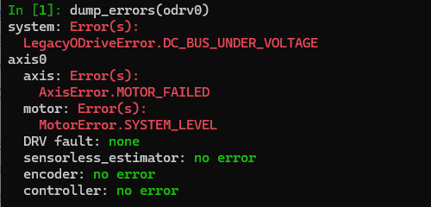

If dump_errors (odrv0) fails to find the specific error, we can also know the specific error by checking the error code (note that all feedback is in decimal), and query the [守护兽驱动协议手册](https://cyberbeast.feishu.cn/docx/BPnQd8reEotLWVxqHFNc9qYZnKh#KKr4dVPH3oQ9r5x5KxocJLmQn4b) for the exception code section

|  |
| --- |
| Python odrv0.axis0.motor.error #电机异常错误码 odrv0.axis0.encoder.error #编码器异常错误码 odrv0.axis0.controller.error #控制异常错误码 odrv0.error #系统异常错误码 |

3.1.5 **Real-time plotting tool**

start_liveplotter(properties[, layout, ...])

Start the real-time plotting tool (please confirm that you have installed the matplotlib library first). For example, print the target position and current position:

|  |
| --- |
| Python start_liveplotter(lambda:[odrv0.axis0.encoder.pos_estimate,odrv0.axis0.controller.input_pos],["pos","pos_target"]) |

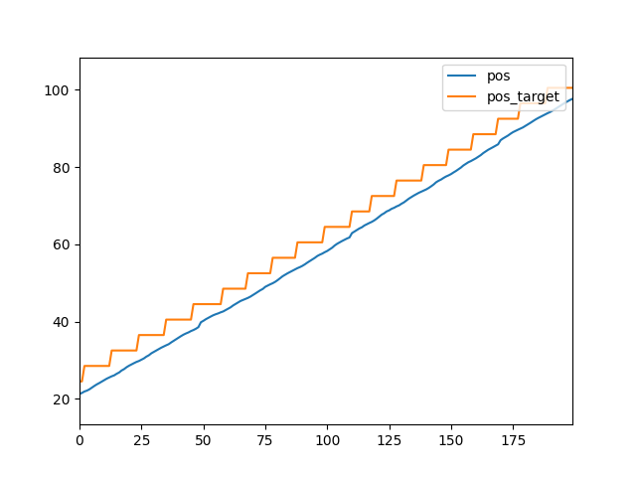

Stop the currently running real-time plotting tool.

|  |
| --- |
| Python stop_liveplotter() |

3.1.6 **Backup and Recovery Parameters**

Open the end point,**do not enter odrivetool**, and perform the following commands in the end point window

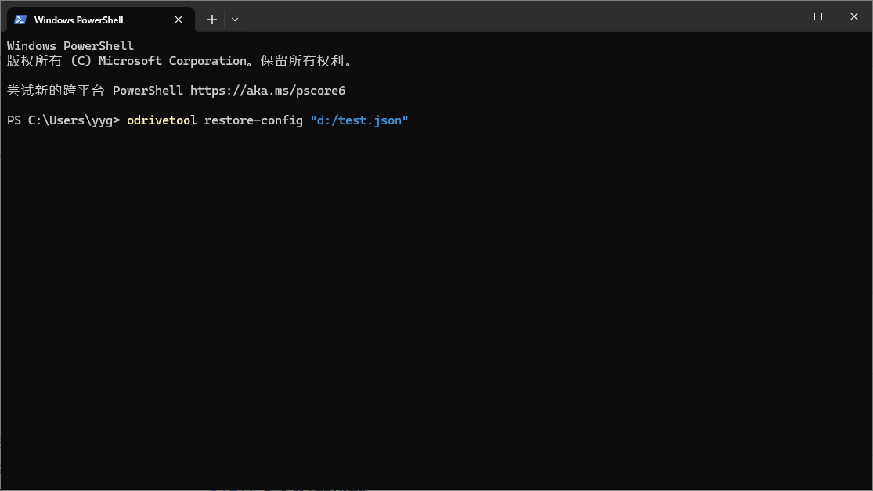

Parameter Backup:

|  |
| --- |
| Plain Text odrivetool backup-config "d:/test.json" |

Among them,d:/test.jsonis the save path and file name that users can freely modify.

When restoring parameters,  **please ensure that the hardware versions of the motors are the same**

The instruction for parameter restoration is:

|  |
| --- |
| Plain Text odrivetool restore-config "d:/test.json" |

3.1.7 **Enter upgrade mode**

To download the firmware, the following instructions need to be executed. For details on firmware download, see  [Firmware Upgrade](https://rcneo0sp7vgy.feishu.cn/docx/OBDNdrWanoj2JSxapQVcLF47nWc#doxcnV4tnHoxU0WXCDI9mqZ7Wjg)

|  |
| --- |
| Plain Text odrv0.enter_dfu_mode() |

3.2 **Motor Calibration**

Normally, the motor has been calibrated before leaving the factory. If a firmware upgrade, drive board disassembly and reassembly, or configuration erasure has been performed, the motor needs to be recalibrated.

[Click to jump to the next section.](https://rcneo0sp7vgy.feishu.cn/docx/OBDNdrWanoj2JSxapQVcLF47nWc#doxcnCepYn3Aupbpafr5y9aJUTc)

When the user first uses the motor, it is necessary to calibrate the motor and encoder (usually calibrated before leaving the factory). Before calibration, please secure the motor or hold it tightly, with the output shaft unloaded. The calibration process is as follows:

|  |
| --- |
| **Warning!**  Before calibration, please run the motor without load and secure it properly! |

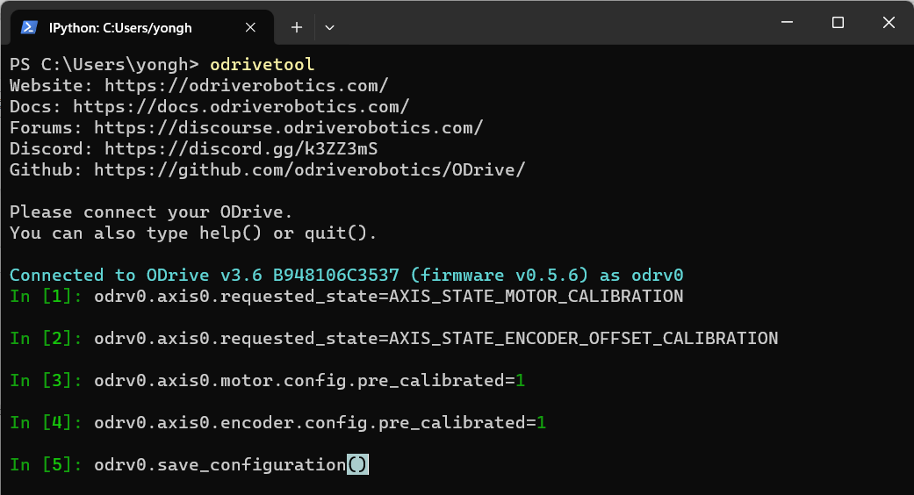

|  |
| --- |
| Plain Text odrv0.axis0.requested_state = AXIS_STATE_MOTOR_CALIBRATION dump_errors(odrv0) odrv0.axis0.requested_state = AXIS_STATE_ENCODER_OFFSET_CALIBRATION dump_errors(odrv0) odrv0.axis0.motor.config.pre_calibrated = 1 odrv0.axis0.encoder.config.pre_calibrated = 1 odrv0.save_configuration() |

The step-by-step explanation is as follows:

* Step 1: Motor parameter self-identification

|  |
| --- |
| Plain Text odrv0.axis0.motor.config.phase_resistance odrv0.axis0.motor.config.phase_inductance |

When measuring the phase resistance and phase inductance of the motor, a sharp beep will be heard. The measurement results of the phase resistance and phase inductance can be viewed via the following commands:

* Step 2: Check the error code

|  |
| --- |
| Python dump_errors(odrv0) |

Check the system error code after the first step. If any red error code appears, you need to restart the motor, then retry, or report to after-sales service.

* Step 3: Encoder Calibration

Calibrate the encoder, including the calibration of the encoder's installation angle and the motor's mechanical angle, as well as the calibration of the encoder itself. During this calibration process, the motor will slowly rotate forward by an angle and then rotate backward by an angle. If it stops after only rotating forward, it indicates an error. Please check the error code through Step 4.

* Step 4: Check the error code

After the encoder calibration in Step 3, check the error code of the system. The commonly occurring error is ERROR_CPR_POLEPAIRS_MISMATCH, indicating that the CPR setting of the encoder is incorrect, or the pole pair setting of the motor is incorrect. Please check/set it via the following command:

|  |
| --- |
| Plain Text odrv0.axis0.encoder.config.cpr odrv0.axis0.motor.config.pole_pairs |

* Step 5: Write the motor calibration success flag
* Step 6: Write the encoder calibration success flag
* Step 7: Store the calibration results and restart

|  |
| --- |
| Plain Text odrv0.axis0.encoder.config.pre_calibrated = 1 odrv0.axis0.motor.config.pre_calibrated = 1 odrv0.save_configuration() |

3.3 **Four control modes**

After completing the motor calibration, the motor can be controlled.

3.3.1 **Position Control**

First, the control mode needs to be changed to position mode

|  |
| --- |
| Python odrv0.axis0.controller.config.control_mode = 3 |

After setting the control mode, we need to set the input mode (input_mode) to determine the algorithm for controlling the position. The following will describe three position control algorithms built into the motor.

**Direct Position Control (Position Control)**

This is a very violent control mode. The motor will reach the target position at full power, and the motor may easily trigger an alarm. Therefore, we do not recommend using it. To use this mode, you need to set the input mode (input_mode) to:

|  |
| --- |
| Python odrv0.axis0.controller.config.input_mode = 1 |

**Filtered Position Control(Filtered Position Control)**

Directly instructing the ODrive controller to reach the original setpoint at the fastest speed may cause motion jitter. This is because ODrive uses Zero Order Hold (ZOH) to maintain the value between each command data transmission. Even if you are using a continuous trajectory generated by an external source, if the trajectory is sent at a moderate frequency, ODrive may chase each step in a jittery manner. You can use a second-order position filter to smooth the trajectory. Using this mode requires setting the input mode (input_mode) to:

|  |
| --- |
| Python odrv0.axis0.controller.config.input_mode = 3 |

A good starting point for adjusting the filter bandwidth is to set it to the same value as the command sending frequency. For example, if you send position commands at 5Hz, set the filter bandwidth to 5.

|  |
| --- |
| Plain Text odrv0.axis0.controller.config.input_filter_bandwidth = 5 |

|  |
| --- |
| **Warning!**  The position filtering mode uses a second-order position filter, which is an "integrating filter". If the motor runs in a single direction for an extended period, the accumulated error will increase, causing the motor to fail to keep up with the target position. Therefore,  **this mode is not suitable for long-term unidirectional operation** . |

**Trajectory Control (Trajectory Control)**

This mode allows users to set acceleration, coasting speed, and deceleration to control the smooth movement of the motor from one position to another. The so-called "trapezoidal" refers to the fact that its speed curve looks like a trapezoid, as shown in the figure below, where orange represents speed and blue represents position:

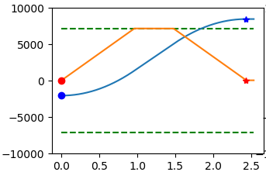

Using this mode requires setting the input mode (input_mode) to:

|  |
| --- |
| Python odrv0.axis0.controller.config.input_mode = 5 |

Adjustable control parameters (this part of the motor initially has default values and can be configured according to requirements):

|  |
| --- |
| Python odrv0.axis0.trap_traj.config.vel_limit #滑行速度最大值，单位turn/s odrv0.axis0.trap_traj.config.accel_limit #加速度最大值，单位turn/s^2 odrv0.axis0.trap_traj.config.decel_limit #减速度最大值，单位turn/s^2 odrv0.axis0.controller.config.inertia #惯量，单位Nm/(turn/s^2) |

vel_limit is the maximum planned trajectory speed. This will set your glide speed.

accel_limit is the maximum acceleration, with the unit of revolutions per second squared

decel_limit is the maximum deceleration, with the unit of revolutions per second squared

controller.config.inertia is a value related to acceleration (in revolutions per second squared) and motor torque. The default value is 0. It is optional, but if properly adjusted, it can improve the system's response. Remember that this value needs to be adjusted according to the system's load/mass.

|  |
| --- |
| All values should be strictly positive (>= 0). |

It should also be noted that the current threshold and speed threshold will still take effect globally. For example, if the maximum coasting speed mentioned above is set higher than the system-level vel_limit, the effective value will be the global vel_limit.

**Run the motor**

In all subsequent control operations, to make the motor rotate, it is necessary to put the motor into the closed-loop control state. The command in odrivetool is as follows:

|  |
| --- |
| Python odrv0.axis0.requested_state = 8 |

At this time, the motor has entered the working state and requires the input of a target,  **please note that the input unit is revolutions on the rotor side**

|  |
| --- |
| Python odrv0.axis0.controller.input_pos = 10 #单位turns |

3.3.2 **Speed Control**

First, the control mode needs to be changed to speed mode

|  |
| --- |
| Python odrv0.axis0.controller.config.control_mode = 2 |

After setting the control mode, we need to set the input mode (input_mode) to determine the algorithm for controlling speed. The following will explain two speed control algorithms built into the motor.

**Direct Velocity Control (Velocity Control)**

This mode is the simplest speed control, where the motor will reach the target speed at full power, and the motor may easily trigger an alarm, so we do not recommend using it. The enabling is as follows:

|  |
| --- |
| Plain Text odrv0.axis0.controller.config.input_mode = 1 |

**Ramped Velocity Control**

The ramp speed control mode refers to gradually increasing the speed to the target value according to a certain slope, which is more gentle than the direct speed control mentioned above, and the enabling is as follows:

|  |
| --- |
| Plain Text odrv0.axis0.controller.config.input_mode = 2 |

Control the acceleration by adjusting the slope, with the acceleration unit being revolutions per second squared on the rotor side:

|  |
| --- |
| Plain Text odrv0.axis0.controller.config.vel_ramp_rate = 0.5 #斜率单位是turn/s^2 |

**Run the motor**

In all subsequent control operations, to make the motor rotate, it is necessary to put the motor into the closed-loop control state. The command in odrivetool is as follows:

|  |
| --- |
| Python odrv0.axis0.requested_state = 8 |

At this time, the motor has entered the working state and requires the input of a target,**please note that the input unit is revolutions per second on the rotor side**

|  |
| --- |
| Python odrv0.axis0.controller.input_vel = 10 #单位turns/s |

3.3.3 **Torque control**

First, the control mode needs to be changed to torque mode

|  |
| --- |
| Python odrv0.axis0.controller.config.control_mode = 1 |

After setting the control mode, we need to set the input mode (input_mode) to determine the algorithm for controlling the torque. The following will explain two torque control algorithms built into the motor.

The unit of torque control is Nm (rotor side), while the current unit in the drive firmware is A. Therefore, it is necessary to set the torque constant to enable the drive to convert Nm to current, thereby driving the motor to output torque as required.

|  |
| --- |
| Plain Text # 力矩常数大约等于 odrv0.axis0.motor.config.torque_constant = 8.23/12.3 |

**Direct Torque Control (Toruqe Control)**

This is the simplest torque (current) control mode, in which the motor will reach the target torque at full power, and the motor may easily trigger an alarm, so we do not recommend using it. The enabling is as follows:

|  |
| --- |
| Plain Text odrv0.axis0.controller.config.input_mode = 1 |

**Ramped Torque Control**

Ramp torque control is very similar to ramp speed control, and the enabling is as follows:

|  |
| --- |
| Plain Text odrv0.axis0.controller.config.input_mode = 6 |

Adjust the slope as follows, where the unit of slope is Nm/s on the rotor side:

|  |
| --- |
| Plain Text odrv0.axis0.controller.config.torque_ramp_rate = 0.1 #斜率单位是Nm/s |

**Run the motor**

In all subsequent control operations, to make the motor rotate, it is necessary to put the motor into the closed-loop control state. The command in odrivetool is as follows:

|  |
| --- |
| Python odrv0.axis0.requested_state = 8 |

At this time, the motor has entered the working state and requires the input of a target,  **please note that the input unit is Newton meters on the rotor side**

|  |
| --- |
| Python odrv0.axis0.controller.input_torque = 1.2 #单位Nm |

3.3.4 **MIT Control**

The motion control mode controls the motor to move to the target position by comprehensively controlling position, velocity, and torque, which can be expressed by the following formula:

where is the target torque, is the position error, is the velocity error, $K_{p}$ is the position control gain, $K_{d}$ is the velocity control gain (or damping coefficient), $T_{ff}$ is the feedforward torque.

The enabling of the motion control mode is as follows:

|  |
| --- |
| Python odrv0.axis0.controller.config.control_mode = 3 odrv0.axis0.controller.config.input_mode = 9 |

Adjust Gain:

|  |
| --- |
| Python odrv0.axis0.controller.input_mit_kp = <float> #位置增益，单位Nm/rad odrv0.axis0.controller.input_mit_kd = <float> #阻尼系数，单位Nm/rad/s |

Adjust the maximum gain value (which will affect parameter accuracy), **note that the unit here is aligned with CAN MIT.**

|  |
| --- |
| Python odrv0.axis0.controller.config.mit_max_kp #默认500，单位Nm/rad odrv0.axis0.controller.config.mit_max_kd #默认5，单位Nm/rad/s odrv0.axis0.controller.config.mit_max_pos #默认12.5，单位rad odrv0.axis0.controller.config.mit_max_vel #默认65，单位rad/s odrv0.axis0.controller.config.mit_max_torque #默认50，单位Nm |

In all subsequent control operations, to make the motor rotate, it is necessary to put the motor into the closed-loop control state. The command in odrivetool is as follows:

|  |
| --- |
| Python odrv0.axis0.requested_state = 8 |

Then perform motion control by inputting input_pos, input_vel, and input_torque. Please note the units:

|  |
| --- |
| Python odrv0.axis0.controller.input_pos = 5 #单位turns odrv0.axis0.controller.input_vel = 30 #单位turn/s odrv0.axis0.controller.input_torque = 2 #单位Nm |

|  |
| --- |
| Please note that the position, velocity, and torque input during **USB control** refer to the **rotor side** , while when using **CAN** for MIT control, the position, velocity, and torque in the protocol refer to the **output shaft side** , which is to maintain consistency with the MIT open-source protocol! |

3.4 **Extended Features**

3.4.1 **Brake (Discharge) Resistor**

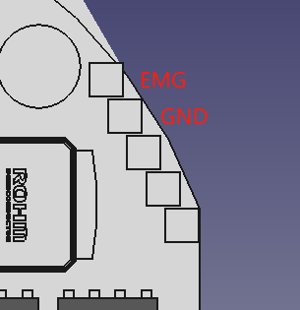

The user can connect a braking resistor (also known as a bleeder resistor) between the braking resistor interfaces (EMG and GND) described in the figure above to shunt and consume the instantaneous current when the bus current flows back into the power supply.

Users can enable it through the following configuration:

|  |
| --- |
| Plain Text odrv0.config.enable_brake_resistor = True odrv0.config.brake_resistance = xxx #设置外接的刹车电阻阻值 odrv0.save_configuration() |

How can the driver be made to automatically discharge? The following two methods can be combined to allow the controller to automatically adjust the discharge current:

* By adjusting the maximum reverse current

|  |
| --- |
| Plain Text odrv0.config.max_regen_current = xxx #反向电流最大值，正数 |

When the reverse current exceeds the above-set value, the driver will shunt the excess current to the bleeder resistor.

* By adjusting the back EMF voltage range

|  |
| --- |
| Plain Text odrv0.config.enable_dc_bus_overvoltage_ramp= True odrv0.config.dc_bus_overvoltage_ramp_start= xxx #分流的电压下限 odrv0.config.dc_bus_overvoltage_ramp_end = xxx #分流的电压上限 |

When the voltage generated due to back electromotive force (EMF) is higher than the above lower limit, the driver starts to shunt to the bleeder resistor; when the voltage is greater than or equal to the above upper limit, the driver applies all the voltage to the bleeder resistor and attempts to shunt. When the voltage is between the above lower and upper limits, the driver proportionally applies the power supply voltage (back EMF voltage) to the bleeder resistor.

Please note that the above two modes can be enabled simultaneously, and the driver will attempt to combine the two methods for discharging.

3.4.2 **Limit Switch**

The drive supports two limit switches (LW1 and LW2), where LW1 is the minimum position and also the home position, and LW2 is the maximum position. It can be externally connected to two-wire switches or three-wire NPN switches. For two-wire switches, one end of the switch is grounded, and the other end is connected to LW1 or LW2.

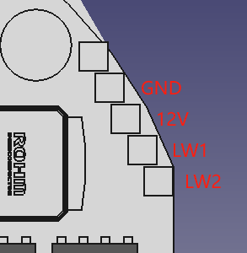

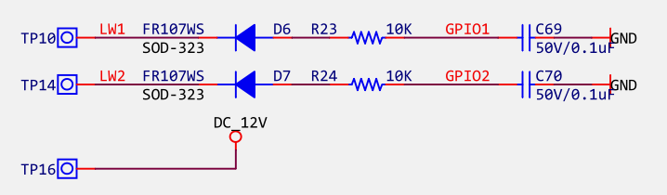

If you want to use two limit switches, please use the following configuration:

|  |
| --- |
| Plain Text odrv0.axis0.min_endstop.config.enabled = True odrv0.axis0.min_endstop.config.gpio_num = 1 odrv0.axis0.max_endstop.config.enabled = True odrv0.axis0.max_endstop.config.gpio_num = 2 |

When the limit switch is triggered, the system will reportMIN_ENDSTOP_PRESSEDorMAX_ENDSTOP_PRESSEDerror, and the host computer can perform relevant operations at this time.

|  |
| --- |
| **Warning!**  Hardware version 3.7 does not support the limit switch function. The limit switch function conflicts with the pulse output function. |

3.4.3 **User-defined zero point**

By default, the position read by the user from the motor and the input value during position control are both based on the zero point of the absolute encoder on the drive. However, in user scenarios, the encoder's zero point is not the user's zero point most of the time, so the user needs to manually set this zero point offset.

Generally speaking, users can locate this zero point through two methods: one is by using a limit switch, and the other is by manually setting the zero point offset, which is the offset value of the user zero point relative to the encoder zero point:

|  |
| --- |
| Python #用户先手动或者通过位置控制转动到期望的用户零点位置后,设置当前位置为零点 odrv0.axis0.encoder.config.index_offset = odrv0.axis0.encoder.pos_estimate + odrv0.axis0.encoder.config.index_offset |

**For single-encoder motors, this value will be cleared upon power-on; for dual-encoder motors, this value will be retained, and the dual-encoder memory range will change with this value.**

3.4.4 **Power-off memory function**

Only dual encoder motors have this function. Please confirm the model of the motor you purchased.

* can memorize the single-turn position, with a memory range of -(reduction ratio/2) to (reduction ratio/2). For 6010-8, the memory range is -4 to 4 (unit: rotor-side revolutions)
* If the above zero point is set, for example, index_offset is set to 2, then the memory range of double encoding becomes -6 to 2
* Assuming the memory range is -4 to 4, when the motor is powered off at position 5, since it can only remember the single-turn position range, the feedback position after the motor is powered on at the current position will be -3, and the motor will handle the over-turn situation internally on its own.

4. **Parameter adjustment**

4.1 **Firmware Upgrade**

4.1.1 **National Download Software**

1. USB (DFU) Programming

**[固件升级.mp4]**

Please note that the national download software can be programmed via the **Type-C interface**, or via the SWD interface (only JLink and DAP are supported). This section mainly takes programming via the Type-C interface as an example.**The Type-C interface cannot supply power, so please use the power interface to supply power before upgrading.**

You need to download the USB driver and the corresponding burning software for the National Burning Software, extract them to any directory, and run them. When installing the driver, select the Win10 file for Win11.

**[国民DFU驱动.zip]**

**[Nations_MCU_Download_Tool_V1.3.4.zip]**

Then, connect the Type-C interface, enter odrivetool, and execute the following command to place the drive in DFU mode:

|  |
| --- |
| Plain Text odrv0.enter_dfu_mode() |

Or click Motor Parameters -> Upgrade on the Motor Wizard



Finally, click on the National Burn-in Software to perform the burn-in operation, as shown in the figure below. Please note that after the burn-in is completed, click "Common Operations" and then click "Reset" to restart the drive and connect to it for debugging through odrivetool normally.

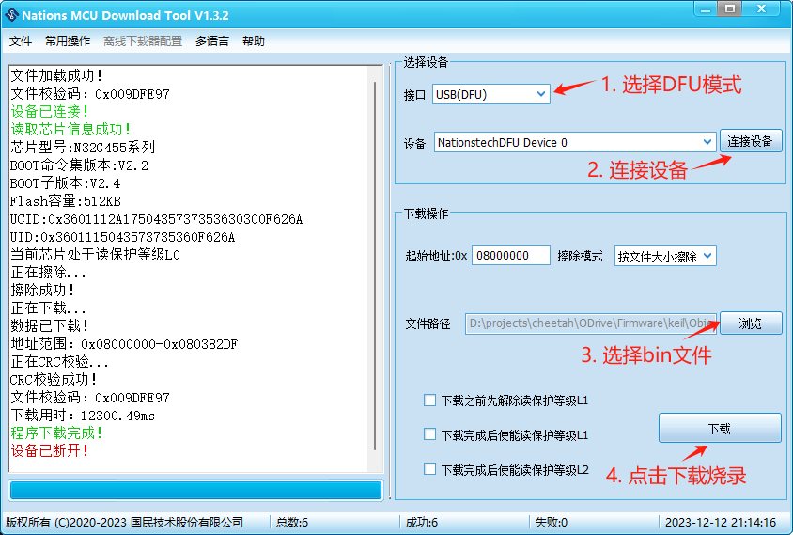

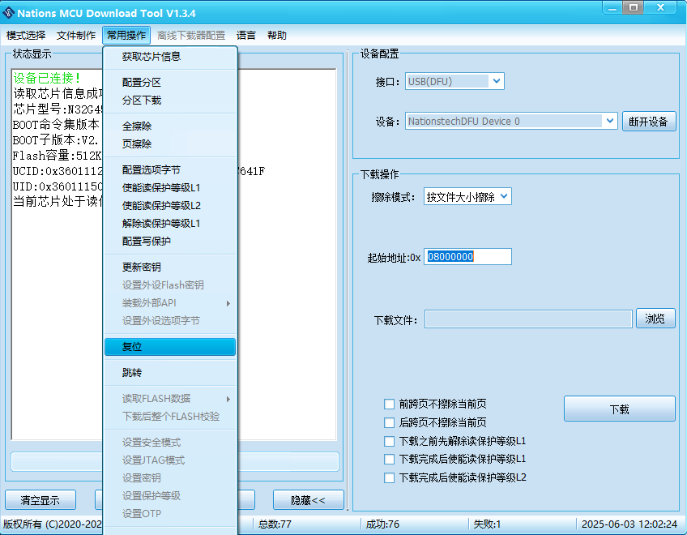

|  |
| --- |
| If an error occurs when Motor 1 is connected to odrivetool or Motor Wizard after the upgrade, please perform the process of erasing the configuration. After the erasure is performed, the motor needs to  **be unloaded**  and recalibrated (  [Motor Calibration Chapter](https://rcneo0sp7vgy.feishu.cn/docx/OBDNdrWanoj2JSxapQVcLF47nWc#doxcnhbXh3hDns3QEgPNwoTQ0Jf)  )   * Motor Sprite Erase Configuration: Long Press to Synchronize * odrivetool：执行 odrv0.erase_configuration() |

If the upgrade is ineffective when the Motor Sprite clicks the upgrade button, please confirm that if the Motor Sprite is a version after 2025.10.11, double-click the upgrade and select the firmware to upgrade.

1. SWD (JLink or DAP) programming

Downloading using the SWD method is similar to the DFU mode, but it requires connection through the SWD debug interface (the interface sequence is as follows), and the corresponding debug tool (JLink or DAP) should be selected in the figure above.

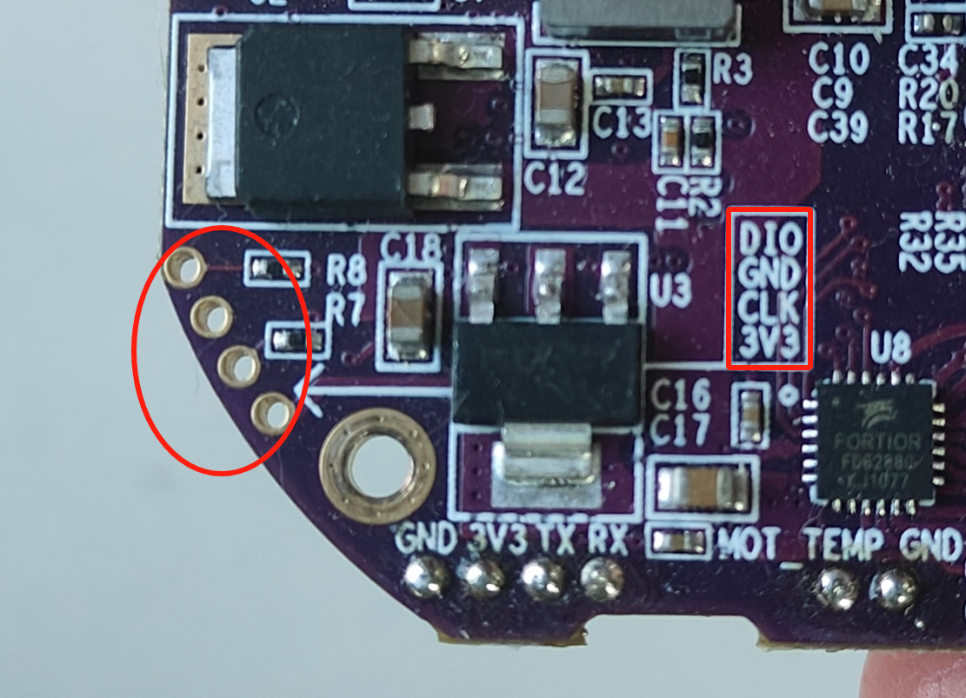

4.1.2 **pyocd**

pyocd is the Python version of openOCD, which can support general debugging tools such as STLink, JLink, and DAP for operations like erasing, programming, and resetting.**Please note that the driver must be connected using the SWD interface.**Regarding the pinout of SWD, refer to the figure above.**There is a 3.3V power supply in the SWD interface, so please do not connect the wires incorrectly to avoid damaging the driver!**

1. pip install pyocdInstallation
2. Flash

First, list the connected debugging tools:

|  |
| --- |
| Plain Text pyocd list |

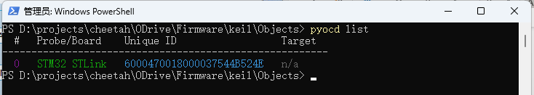

Then, execute the following command to flash the bin file:

|  |
| --- |
| Plain Text pyocd load .\ODrive_N32G455.bin -a 0x8000000 |

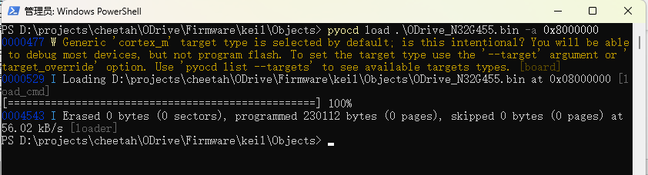

4.2 **PID and Parameter Tuning for Different Control Modes**

The video cover serves as an index, allowing users to jump to specific points on the timeline according to their own needs

**[202506061025.mp4]**

|  |
| --- |
| Plain Text odrv0.axis0.controller.config.pos_gain=20.0 odrv0.axis0.controller.config.vel_gain=0.16 odrv0.axis0.controller.config.vel_integrator_gain=0.32 |

The following process can provide a reference for users to adjust PID parameters:

1. Set the initial value of PID
2. Set vel_integrator_gain to 0
3. odrv0.axis0.controller.config.vel_integrator_gain=0

Method for adjusting vel_gain:

1. Rotate the motor in speed control mode. If the rotation is not smooth, with jitter or vibration, reduce vel_gain until the rotation becomes smooth.
2. Then, increase vel_gain by approximately 30% each time until obvious jitter occurs
3. At this point, reducing vel_gain by approximately 50% will stabilize it
4. Method for adjusting pos_gain:
5. Try rotating the motor in position mode. If the rotation is not smooth, with pulling or vibration, reduce pos_gain until the rotation is smooth.
6. Next, increase pos_gain by approximately 30% each time until the position control shows obvious overshoot (i.e., each time the position control motor exceeds the target position and then oscillates back to the target position)
7. Then, gradually reduce pos_gain until the overshoot phenomenon disappears
8. After the above 4-step adjustment, vel_integrator_gain can be set to 0.5*bandwidth*vel_gain, where bandwidth is the system control bandwidth. What is control bandwidth? For example, if the time from when the user sets the target position to when the motor actually reaches the target position is 10ms, then the control bandwidth is 100Hz, and vel_integrator_gain = 0.5*100*vel_gain.

During the above parameter tuning process, it is recommended to use [3.1 Real-time Plotting Tool](https://rcneo0sp7vgy.feishu.cn/docx/OBDNdrWanoj2JSxapQVcLF47nWc#doxcnzbBt93peMHW41gtatmU4uc)  to view the parameter tuning results in real-time using graphical means, avoiding errors caused by visual perception. If using the Motor Wizard, the PID adjustment results are "what you see is what you get". The following figure shows the PID parameter illustration:

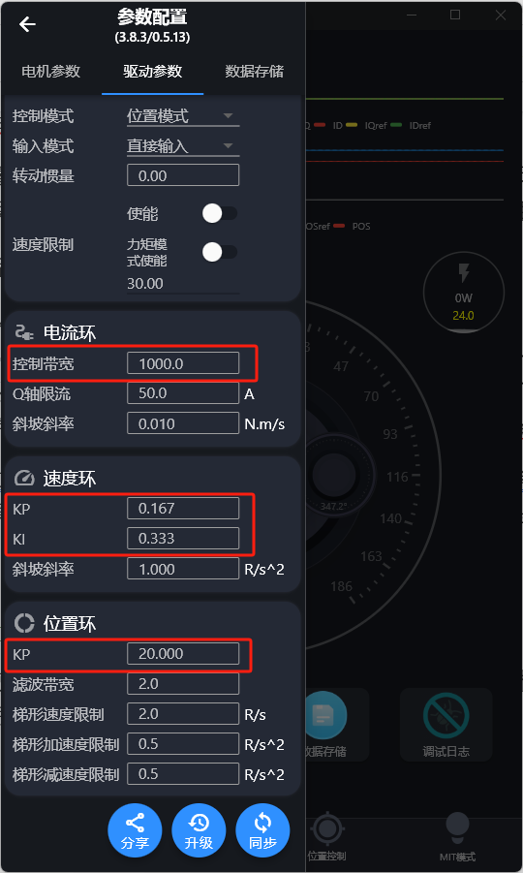

4.3 **Key Threshold (limits)**

4.3.1 **Voltage Threshold**

If the motor reports an under-voltage or over-voltage alarm, it is usually related to this threshold.

|  |  |
| --- | --- |
|  |  |

* **odrivetool**

Low voltage alarm threshold (V), default value is 15V; Overvoltage alarm threshold (V), default value is 64V.

|  |
| --- |
| Python odrv0.config.dc_bus_undervoltage_trip_level #低电压告警门限（V） odrv0.config.dc_bus_overvoltage_trip_level #超电压告警门限（V） |

* **Motor Sprite**

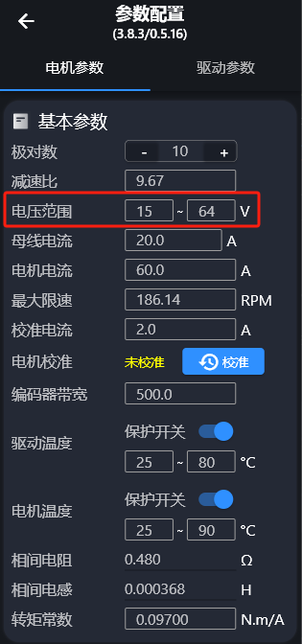

After changing parameters in the Motor Wizard, remember to click Sync to save the parameters while the motor is in an idle state.

|  |
| --- |
| When using a power supply of 24V or lower, remember to change the lower voltage limit to 10V or 8V on the host computer. Otherwise, under-voltage errors may be reported frequently during use. |

4.3.2 **Current Threshold**

If the motor reports an overcurrent alarm, it is usually related to this threshold.

|  |  |
| --- | --- |
|  |  |

Incomplete, to be updated. Please adjust the parameter of bus current (odrv0.config.dc_max_positive_current) to 200A to prevent unnecessary overcurrent alarms of the motor. The motor current (odrv0.axis0.motor.config.current_lim) is a maximum of 80A, with a default of 60A.

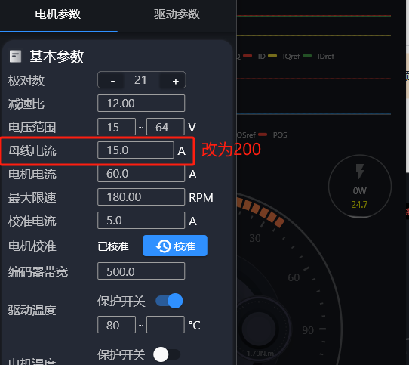

4.3.3 **Temperature Protection**

The temperature protection on the drive is enabled by default, with a default value of 25°C to 80°C. When the temperature reaches the lower limit of the set range, the motor starts temperature protection, and the motor torque begins to decrease; as the motor temperature rises and gets closer to the upper limit of temperature protection, the motor force becomes smaller, until the motor stops running (this process does not generate an error).

If you don't want to start protection at room temperature, you can try changing the range to 70°C - 90°C (simultaneously set the drive temperature range and motor temperature range).

Only when the motor temperature rises sharply will the motor generate an error due to temperature.

* **odrivetool**

Enable motor drive board temperature protection and motor temperature protection switch, 1 for on, 0 for off.

|  |
| --- |
| Python odrv0.axis0.motor.motor_thermistor.config.enabled = 1 #电机温度保护使能 odrv0.axis0.motor.fet_thermistor.config.enabled = 1 #驱动板温度保护使能 |

Motor Temperature Protection Threshold

|  |
| --- |
| Python odrv0.axis0.motor.motor_thermistor.config.temp_limit_lower #下限 odrv0.axis0.motor.motor_thermistor.config.temp_limit_upper #上限 |

Drive board temperature protection threshold

|  |
| --- |
| Python odrv0.axis0.motor.fet_thermistor.config.temp_limit_lower #下限 odrv0.axis0.motor.fet_thermistor.config.temp_limit_upper #上限 |

Get Temperature

|  |
| --- |
| Python # 获取温度 odrv0.axis0.motor.motor_thermistor.temperature #电机温度 odrv0.axis0.motor.fet_thermistor.temperature #驱动板温度 |

* **Motor Sprite**

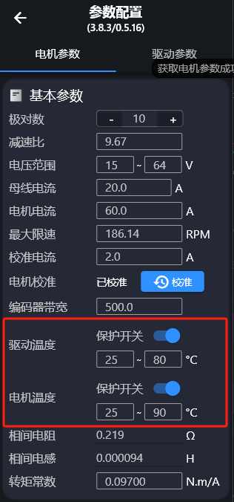

4.3.4 **Speed Threshold**

The speed threshold sets the maximum speed that the motor can reach

* **odrivetool**

Global speed threshold enable, 1 for on, 0 for off

|  |
| --- |
| Python odrv0.axis0.controller.config.enable_vel_limit = 1 |

Global Speed Limit

|  |
| --- |
| Python odrv0.axis0.controller.config.vel_limit = 30 |

The above instruction limits it to 30 turns per second (turn/s). Please note that by default, this speed limit does not apply in pure torque mode, but it can be enabled by turning on the following switch:

|  |
| --- |
| Plain Text odrv0.axis0.controller.config.enable_torque_mode_vel_limit = 1 |

* **Motor Sprite**

The values entered below are all global speed limits. The upper switch in the right figure controls whether to enable the global speed limit, and the lower switch controls whether this speed limit is enabled in pure torque mode.

|  |  |
| --- | --- |
|  |  |

5. **Communication Protocol Usage**

Communication Protocol Manual:[电机驱动协议手册](https://bcnyljrhe70u.feishu.cn/docx/BPnQd8reEotLWVxqHFNc9qYZnKh)

5.1 **CANSimple**

5.1.1 **Wiring Instructions**

For hardware versions v3.7, 3.9, 3.10, and 3.11, wire connections should be made according to the wire sequence shown in the first figure; for hardware versions v3.8 and 4.1, wire connections should be made according to the wire sequence shown in the second figure. Normally, the dominant voltage of CANH should be around 3.5V, and the dominant voltage of CANL should be around 1.5V. When measured with a multimeter, the voltage of CANH and CANL to ground should be 2.5V.

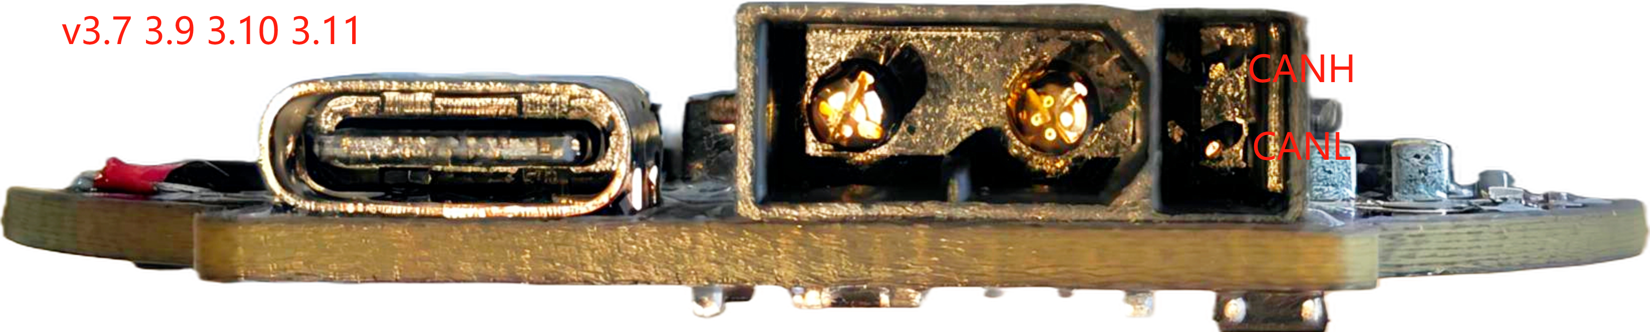

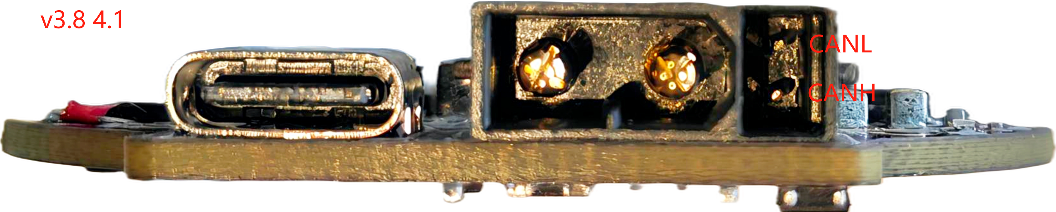

|  |
| --- |
| **Warning!**  All CAN devices need to share a common ground; otherwise, CAN may not function properly. |

5.1.2 **120 Ω impedance matching**

Please ensure that the total impedance on the bus is approximately 60Ω. A standard CAN network requires**120Ω at each end (control end and the farthest motor end), totaling 60Ω**. A software-controlled 120Ω resistor switch is integrated inside the board, and it can be turned on according to the following instructions:

* odrivetool

|  |
| --- |
| Python odrv0.can.config.enable_r120 = True |

* Motor Sprite

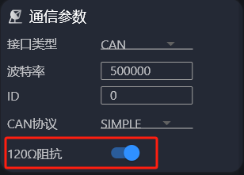

5.1.3 **Switch Communication Protocol**

* odrivetool

The default protocol of the drive is CAN Simple. If the user switches to the CANOpen protocol, they need to switch back to CAN Simple using the following command:

|  |
| --- |
| Plain Text odrv0.can.config.protocol = 1 |

Please note that the communication interface supports RS485, pulse direction, and PWM simultaneously. Ensure that the communication interface is CAN through the following command:

|  |
| --- |
| Plain Text odrv0.config.comm_intf_mux = 0 |

* Motor Sprite

In the Motor Wizard, you can also switch the physical interface and CAN protocol version in Motor Parameters -> Communication Parameters.

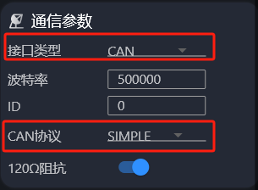

5.1.4 **Baud Rate Change**

The factory default rate is 500Kbps, and the maximum communication rate is 1Mbps. The baud rate can be changed via odrivetool and Motor Wizard.

* odrivetool

|  |
| --- |
| Python  odrv0.can.config.baud_rate = 500000 |

* Motor Sprite

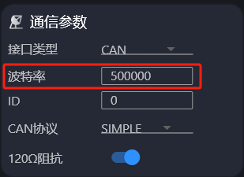

5.1.5 **Periodic Message**

Users can configure the motor to periodically send messages to the host computer without the host computer sending request messages to the motor. The periodic messages can be enabled/disabled through a series of configurations under odrv0.axis0.config.can (a value of 0 indicates disabled, and other values indicate the period time in ms), as shown in the following table:

|  |  |  |  |  |
| --- | --- | --- | --- | --- |
| Message | cmd_id | Content | odrivetool Configuration | Default Value |
| Heartbeat | 0x01 | Heartbeat Feedback | odrv0.axis0.config.can.heartbeat_rate_ms | 100 |
| Get_Encoder_Estimates | 0x09 | Encoder position and speed feedback | odrv0.axis0.config.can.encoder_rate_ms | 10 |
| Get_Motor_Error | 0x03 | Motor error feedback | odrv0.axis0.config.can.motor_error_rate_ms | 0 |
| Get_Encoder_Error | 0x03 | Encoder Error Feedback | odrv0.axis0.config.can.encoder_error_rate_ms | 0 |
| Get_Controller_Error | 0x03 | Control Error Feedback | odrv0.axis0.config.can.controller_error_rate_ms | 0 |
| Get_Iq | 0x14 | Q-axis current feedback | odrv0.axis0.config.can.iq_rate_ms | 0 |
| Get_Bus_Voltage_Current | 0x17 | Bus voltage and current feedback | odrv0.axis0.config.can.bus_vi_rate_ms | 0 |

**When leaving the factory, the first two types of periodic messages are enabled by default** , so when users monitor the CAN bus, they will see the two types of messages being broadcast at the set intervals. Users can disable them using the following commands:

|  |
| --- |
| Plain Text odrv0.axis0.config.can.heartbeat_rate_ms = 0 odrv0.axis0.config.can.encoder_rate_ms= 0 |

Use Motor Wizard to turn off and then turn on Motor Wizard -> Find the above command in ODrive parameters, type 0, press Enter, and click Sync Save.

|  |  |
| --- | --- |
|  |  |

Get_Encoder_Estimates (0x09) feedback content will only provide current position and velocity information after the motor **enters closed-loop control** ; in idle state, it will only provide the position and velocity information from the last time it entered closed-loop control (or 0 if it has never entered closed-loop control).

5.1.6 **Change Motor ID**

The drive ID is unique on the bus, ranging from 0 to 63 . If the user has multiple motors connected in series on the bus, different IDs need to be set for each motor. The user can modify the ID via USB or bus:

* odrivetool

|  |
| --- |
| Plain Text odrv0.axis0.config.can.node_id = xxx |

* Motor Sprite

Open the Motor Wizard, connect to the motor, click "Motor Parameters", modify the ID in the "Communication Parameters" section, and click "Synchronize" to save it to the drive.

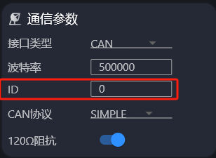

5.1.7 **Get detailed error information**

Searching for "heartbeat" in the protocol manual can show the detailed description of the CAN heartbeat frame. The heartbeat frame contains the device's current status information (as shown in the figure below), which is used to quickly determine if there are any anomalies.

Among them, byte5 (Flags) is used to identify the status or fault type of the current device and can serve as a preliminary basis for judgment; byte0 (Axis_Error) records the axis-level error code, which is also helpful for troubleshooting. It should be noted that **these error messages usually only indicate the appearance of the problem, and the real cause of the fault still needs to be combined with the prompts in Flags** and further analyzed by referring to the corresponding detailed error (Get_Error, as shown in the figure below) description.

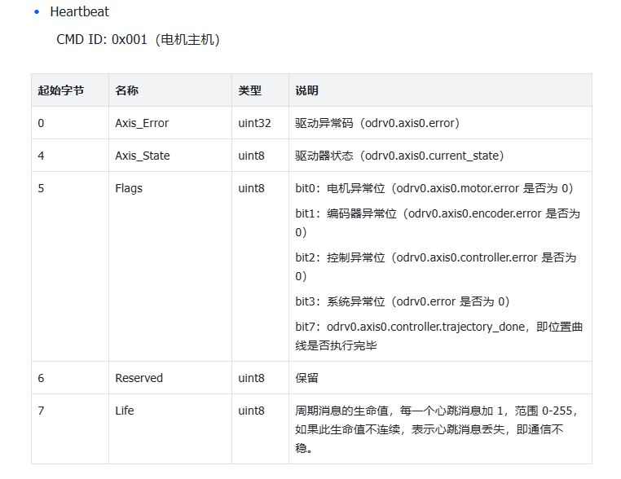

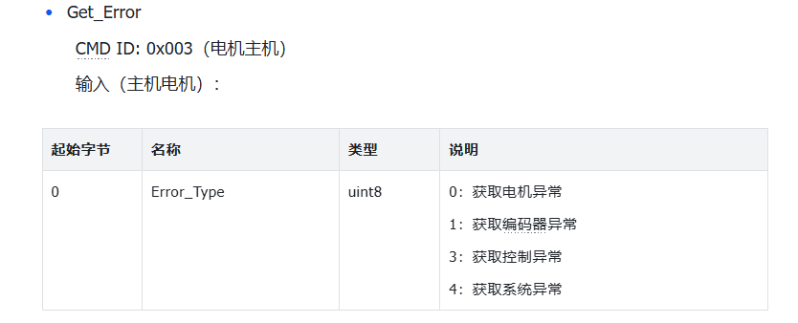

For example, when Flags is 0x82, converting it to binary results in 1000 0010, indicating an encoder anomaly (bit7 is the flag bit for whether the position trapezoidal curve has completed execution and does not participate in the anomaly). At this time, it is necessary to obtain detailed encoder anomaly information according to Function Code 0x03 Get_Error, as shown in the instruction manual screenshot above.

After sending 01 to function code 0x03, the detailed encoder exception is obtained as shown below.



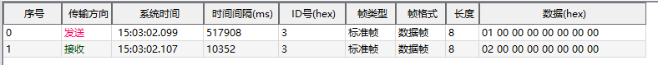

0x00000002, we found[the error code in the protocol manual](https://cyberbeast.feishu.cn/docx/BPnQd8reEotLWVxqHFNc9qYZnKh#KKr4dVPH3oQ9r5x5KxocJLmQn4b), corresponding to encoder error

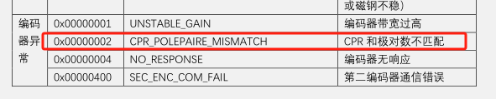

This exception usually occurs when the number of pole pairs configured in the motor drive does not match the actual number of pole pairs of the motor, often happening during the motor calibration process.

Each time an exception occurs, multiple exceptions may occur simultaneously. Only by corresponding to all exception codes can the root cause of the motor exception be determined. Thus, the process of obtaining the motor exception code via CAN ends.

5.1.8 **RxSdo Usage**

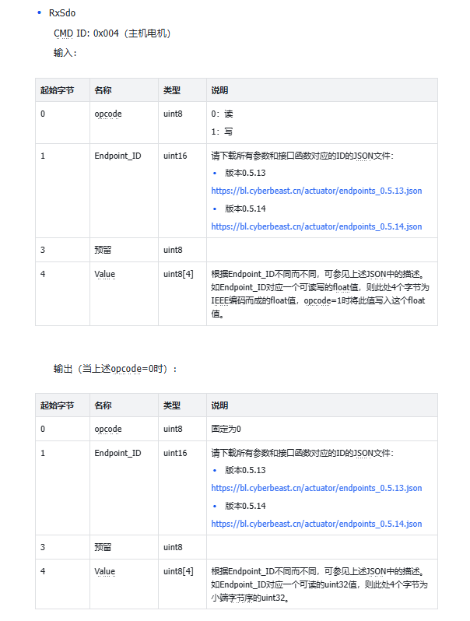

CAN RxSdo and TxSdo send data in little-endian format. First, you need to confirm the corresponding json file (downloaded from the manual) based on your own firmware version (for details of the firmware version, see  [2.1 Motor Parameters](https://rcneo0sp7vgy.feishu.cn/docx/OBDNdrWanoj2JSxapQVcLF47nWc#doxcno63tmK0cyt0Df21vNXZqZg))

For example, I want to change.dc_max_positive_current to 40 (this data is of type float), the first digit of the written data is 01 , the found id is 98 (STW 0.5.14 json), the corresponding hexadecimal code is 0x0062 , the IEEE corresponding to 40 is as shown in the figure: 42 20 00 00 . So, it is necessary to send: can_id is 0x005, the sent content is: 01 62 00 00 00 00 20 42 .

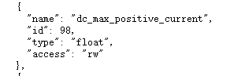

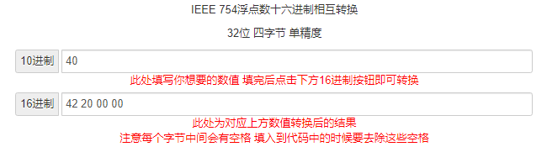

For uint8 variables / bool variables, for example, if I want to change the working state of the motor, the first bit of the written data is 01 , the id of request_state is found to be 137 (0.5.11), and the corresponding hexadecimal is 0x0089 , the written state is 08 , and the sent content is 01 89 00 00 08 00 00 00

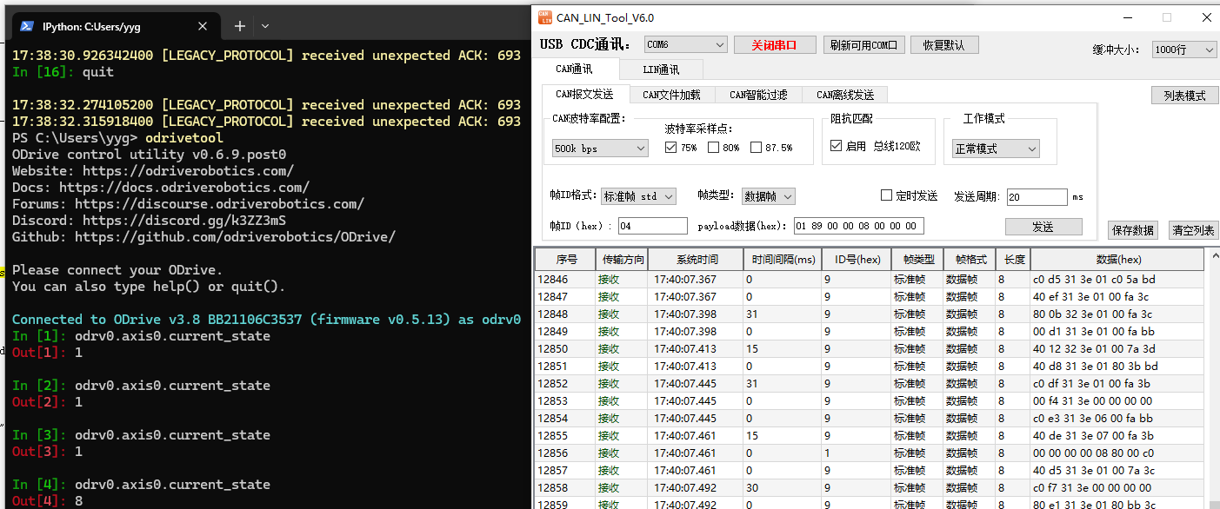

5.1.9 **Communication timeout stopped**

Currently, CAN has a communication timeout stop function, which can achieve the following effect: Starting from the first transmission of a CAN command, if the CAN communication is interrupted for longer than the set time, a motor error will be reported. **Communication needs to be restored and this error cleared**  for the motor to operate normally. For example, assuming it is set to 2000 (unit: ms), if the interval between the motor's first reception of a CAN communication command and its second reception exceeds 2000ms, the motor will generate an error.

The parameter is set to 0 by default to turn off, with the unit of the set value being ms. Once set, the instruction takes effect immediately. The instruction is as follows:

* odrivetool

After setting, it needs to be saved in the idle state.

|  |
| --- |
| Python odrv0.can.config.break_timeout = 2000 #设定超时时间为2000ms |

The motor will report an error after timeout:

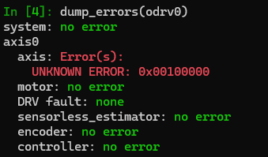

* Motor Sprite

ODrive Parameters -> Follow the instructions below -> Type Enter, then click Sync in idle state.

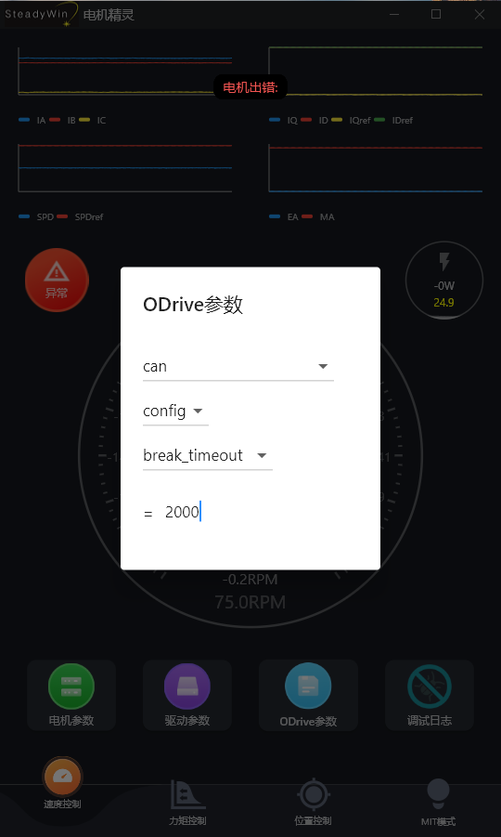

Motor error code after timeout:

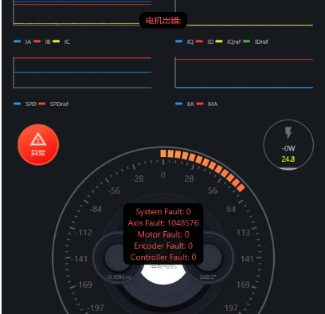

5.2 **CANOpen**

Regarding[wiring instructions](https://rcneo0sp7vgy.feishu.cn/docx/OBDNdrWanoj2JSxapQVcLF47nWc#doxcnmueEuSm398roXjI0HPff0g),[impedance matching](https://rcneo0sp7vgy.feishu.cn/docx/OBDNdrWanoj2JSxapQVcLF47nWc#doxcnLeOe9KtohiTdDhqathKc0e),[baud rate change](https://rcneo0sp7vgy.feishu.cn/docx/OBDNdrWanoj2JSxapQVcLF47nWc#doxcnRSBno7L6rJNUXb5TPIIch0)and the synchronous CANSimple section, please refer to them on your own.

5.2.1 **Switch Communication Protocol**

* odrivetool

The default protocol of the drive is CAN Simple. If users need to use CANOpen, please choose the communication method by either of the following two methods:

|  |
| --- |
| Plain Text odrv0.can.config.protocol = 2 |

Please note that the communication interface supports RS485, pulse direction, and PWM simultaneously. Ensure that the communication interface is CAN through the following command:

|  |
| --- |
| Plain Text odrv0.config.comm_intf_mux = 0 |

* Motor Sprite

In the Motor Wizard, you can also switch the physical interface and CAN protocol version in Motor Parameters -> Communication Parameters.

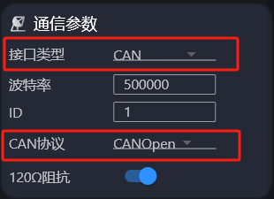

5.3 **RS485(Modbus RTU)**

Please confirm that the hardware version is v3.10, 3.11, or 4.1 before using this feature.

5.3.1 **Wiring Instructions**

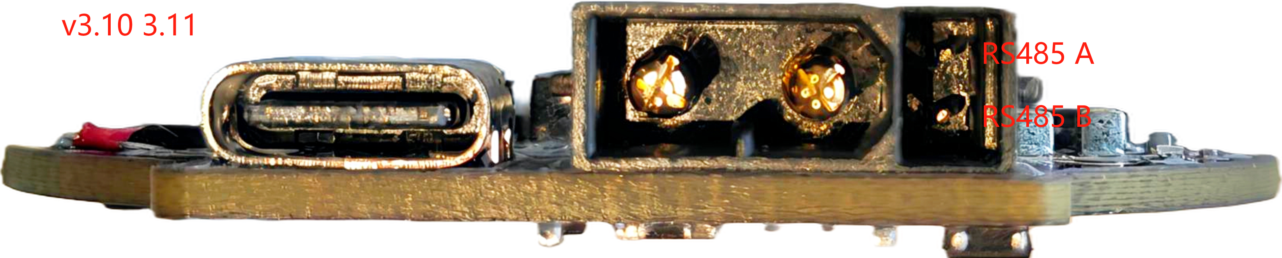

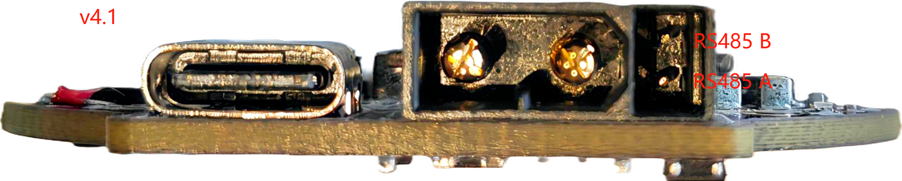

5.3.2 **Switch Communication Protocol**

* odrivetool

Please note that on hardware versions greater than or equal to 3.10, the communication interface simultaneously supports RS485, pulse direction, and PWM. Ensure that the communication interface is CAN using the following command:

|  |
| --- |
| Python odrv0.config.comm_intf_mux = 1 |

* Motor Sprite

In the Motor Wizard, or in the communication parameters, you can switch the physical interface.

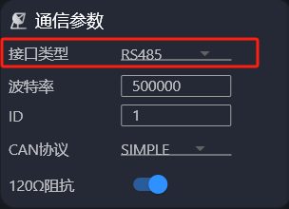

5.3.3 **Baud Rate Change**

Based on RS485 Modbus RTU, the maximum communication rate is 115200bps, and the factory default rate is 115200bps. The baud rate can be changed via odrivetool and Motor Wizard.

* odrivetool

|  |
| --- |
| Python odrv0.config.uart_c_baudrate = 115200 |

* Motor Sprite

After clicking on ODrive parameters, enter as shown in the figure

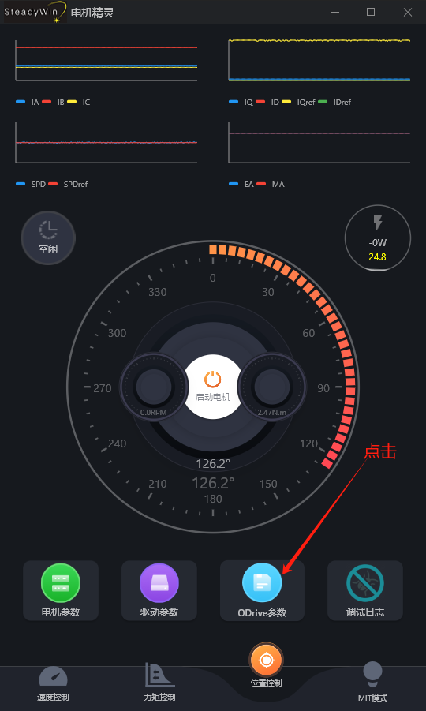

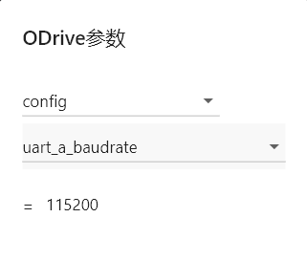

5.3.4 **Random endpoint access usage**

To be updated.

5.4 **PWM Input Control**

Please confirm that the hardware version is v3.10, 3.11, 4.1, or higher before using this feature.

This feature supports controlling various writable parameters, such as position, velocity, or torque, through standard RC PWM signals (1ms–2ms pulse width, 50Hz). By configuring GPIO pins to PWM mode and setting up mapping relationships, direct control of the motor from an RC receiver or other PWM controllers can be achieved.

5.4.1 **Wiring Instructions**

The PWM signal line is connected to the position shown in the figure. For hardware versions 3.10 and 3.11, wire according to the first figure; for hardware version 4.1, wire according to the first figure. This interface supports PWM signals of 5V and below, and requires the PWM signal to share the same ground with the motor driver.

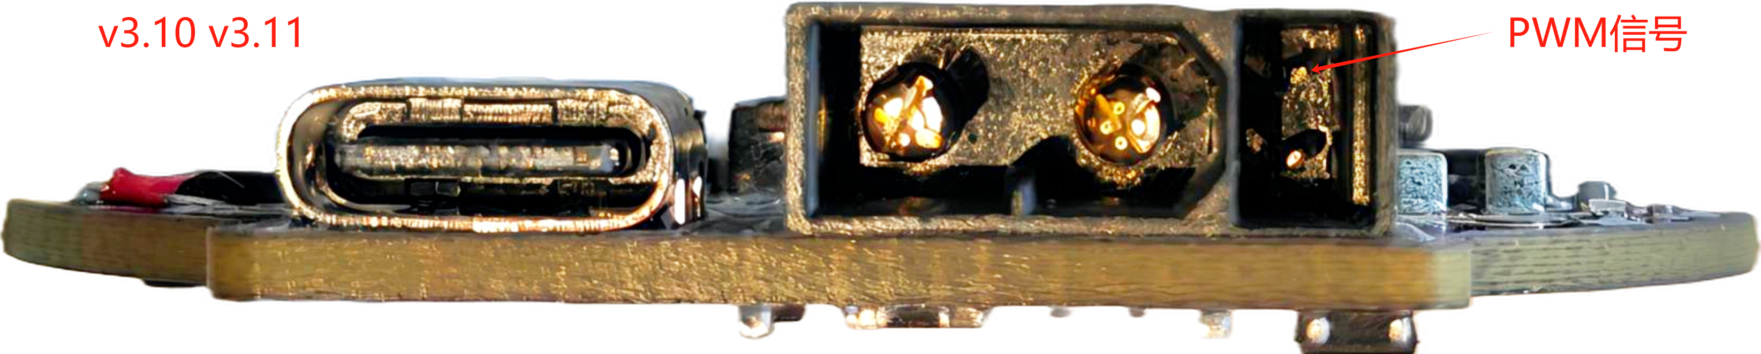

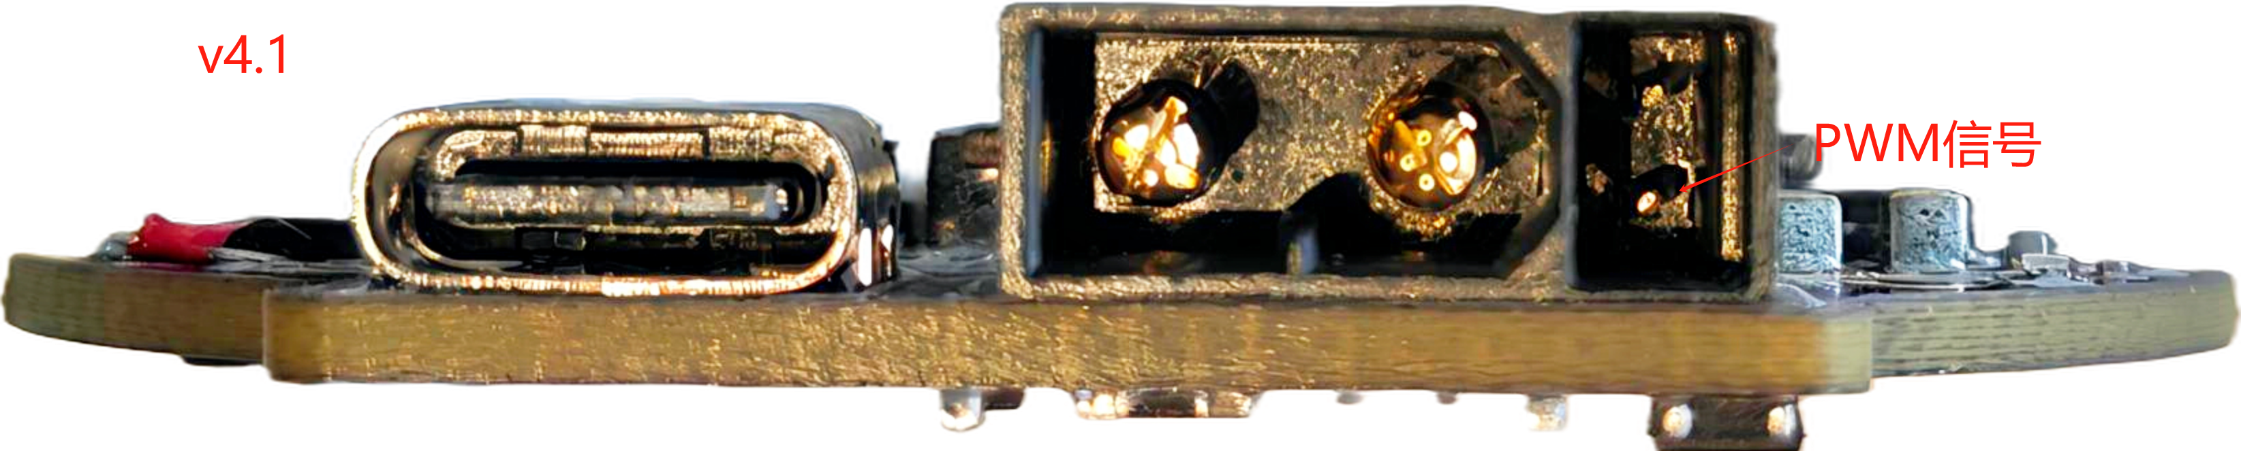

5.4.2 **Software Configuration**

* Switch the communication interface to PWM:

|  |
| --- |
| Python odrv0.config.comm_intf_mux = 3 |

In the motor wizard, or in the communication parameters, you can switch the physical interface. Please click on the motor parameters to find this item.

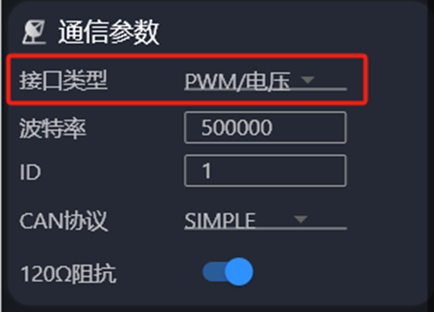

Subsequent configuration does not support Motor Genie configuration. Please first install odrivetool according to [1.3.2](https://rcneo0sp7vgy.feishu.cn/docx/OBDNdrWanoj2JSxapQVcLF47nWc#doxcn9ZAfww9rdPOMuxGqeaTR4Z)  before proceeding with subsequent configuration.

* Set GPIO to PWM mode

|  |
| --- |
| Python odrv0.config.gpio1_mode = GPIO_MODE_PWM |

* Set PWM mapping control mode

It can be mapped to speed/position/torque mode, and one of the following three modes can be configured as needed.

Speed Mode

Please set the motor control mode to[ramp speed mode](https://rcneo0sp7vgy.feishu.cn/docx/OBDNdrWanoj2JSxapQVcLF47nWc#doxcnKURcqfVc8UnD6fzmjHFYSf)(control_mode = 2, input_mode = 2)

|  |
| --- |
| Python odrv0.config.gpio1_pwm_mapping.endpoint = odrv0.axis0.controller._input_vel_property |

Position Mode

Please set the motor control mode to[Trapezoidal Curve Position Mode](https://rcneo0sp7vgy.feishu.cn/docx/OBDNdrWanoj2JSxapQVcLF47nWc#doxcnUyKwtvqLWXsV6KWtSxEked) (control_mode = 3, input_mode = 5)

|  |
| --- |
| Python odrv0.config.gpio1_pwm_mapping.endpoint = odrv0.axis0.controller._input_pos_property |

Torque Mode

Please set the motor control mode to[ramp torque mode](https://rcneo0sp7vgy.feishu.cn/docx/OBDNdrWanoj2JSxapQVcLF47nWc#doxcnIcocXB561OhOpt1qfLOtVf)(control_mode = 1, input_mode = 6)

|  |
| --- |
| Python odrv0.config.gpio1_pwm_mapping.endpoint = odrv0.axis0.controller._input_torque_property |

* Set PWM mapping parameters

|  |
| --- |
| Python odrv0.config.gpio1_pwm_mapping.min = -8.0 odrv0.config.gpio1_pwm_mapping.max = 8.0 |

min and max define the range of control values to which the PWM pulse width (1ms to 2ms) is mapped. Internally, the driver will linearly map the pulse width value to a real value within the range of [min, max]. min and max can be set to any value as needed.

* Save Configuration (Optional)

|  |
| --- |
| Python odrv0.save_configuration() |

After completing the above configuration, please enable the motor to enter closed-loop control to perform PWM control.

5.5 **Pulse/Direction Control**

Please confirm that the hardware version is v3.10, 3.11, 4.1, or higher before using this feature.

This function conflicts with the limit switch function. This function is the simplest way to control the drive, but it is also the most primitive and vulnerable method. Therefore, unless the situation is special, please do not use this control method.

This function supports controlling brushless motors through the traditional Step/Dir (pulse/direction) interface, enabling a control method compatible with ordinary stepper motor drivers. In this mode:

* Step (pulse) signal: Each rising edge corresponds to the motor moving a preset step (determined by steps_per_circular_range), maximum recommended Step frequency: 50kHz
* Dir (Direction) signal: the level determines the direction of motion (high level for clockwise / low level for counterclockwise)

5.5.1 **Wiring Instructions**

Step (pulse signal) and Dir (direction signal) signal lines are connected to the position shown in the figure. This interface supports pulse signals of 5V and below. Please make sure that Step and Dir signals are **on the same ground as** the motor drive, otherwise the signal may fail to recognize.

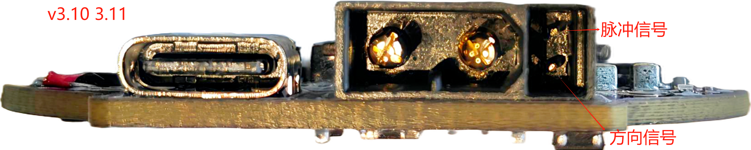

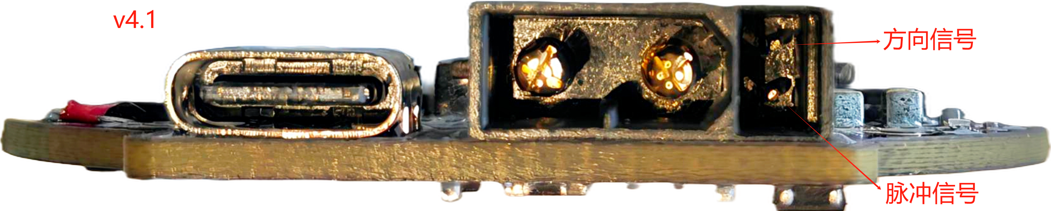

5.5.2 **Software Configuration**

* Switch the communication interface to Step/Dir:

|  |
| --- |
| Python odrv0.config.comm_intf_mux = 2 |

In the motor wizard, or in the communication parameters, you can switch the physical interface. Please click on the motor parameters to find this item.

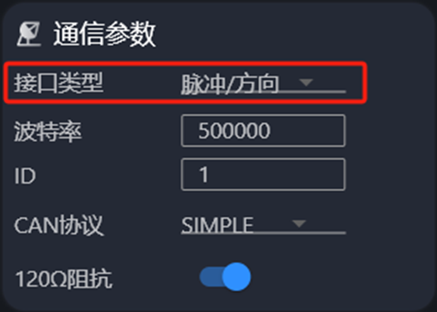

Subsequent configuration does not support Motor Genie configuration. Please first install odrivetool according to [1.3.2](https://rcneo0sp7vgy.feishu.cn/docx/OBDNdrWanoj2JSxapQVcLF47nWc#doxcn9ZAfww9rdPOMuxGqeaTR4Z)  before proceeding with subsequent configuration.

* Set GPIO to Step/Dir mode

|  |
| --- |
| Python odrv0.axis0.config.step_gpio_pin = 6 odrv0.axis0.config.dir_gpio_pin = 7 |

* Configure Step/Dir pins

|  |
| --- |
| Python odrv0.config.gpio6_mode = GPIO_MODE_DIGITAL_PULL_UP odrv0.config.gpio7_mode = GPIO_MODE_DIGITAL_PULL_UP |

* Enable Step/Dir

|  |
| --- |
| Python odrv0.axis0.config.enable_step_dir = True |

Please note that to exit pulse/direction control, you need to set enable_step_dir to False, then enter the idle state, and finally return to closed-loop control.

* Enable Circular Setpoint (Optional)

To address the precision drift issue when dealing with large-range target positions, ODrive provides circular setpoint support, i.e., the target position wrap-around mode. Using circular setpoints can keep floating-point errors within a controllable range. If the motor is commanded to exceed the circular range, the position setpoint will automatically wrap around to stay within the range.

Enable the circular setpoint mode of the controller

|  |
| --- |
| Python odrv0.axis0.controller.config.circular_setpoints = True |

Set the circular position range (unit: turns), the value of the set point will be limited to the range of 0 to this value, and will wrap around if exceeded

|  |
| --- |
| Python # 128圈为一个闭环 odrv0.axis0.controller.config.circular_setpoint_range = 128.0 |

The number of STEP pulses required within the corresponding circular position range determines the displacement amount of 1 step

|  |
| --- |
| Python  # 每圈 1024 个 step odrv0.axis0.controller.config.steps_per_circular_range = 128 * 1024 |

After completing the above configuration, please enable the motor to enter closed-loop operation under  **position mode**  to perform pulse control.

|  |
| --- |
| Python odrv0.axis0.controller.config.control_mode = 3 |

* Save Configuration (Optional)

|  |
| --- |
| Python odrv0.save_configuration() |

6. **SDK and Example Programs**

6.1 **C/C++ SDK**

Based on the CAN Simple protocol, you can download the following C/C++ SDK for integration:[Beijing Shouhoushou Technology Co., Ltd./MWMotorSDK](https://gitee.com/cyberbeast/mwmotorsdk)

Quick Start with SDK:[MWMotor SDK快速上手](https://bcnyljrhe70u.feishu.cn/docx/KRJcdmc3yovKxsxNnXOcNmppnwf)

Please refer to the detailed test cases on the above open-source website for integration testing.

6.2 **Python SDK**

Please first refer to the steps in Section 1.3.2 to install odrivetool (pip install --upgrade odrive).

Below are three examples:

1. **Practical: Power-on Calibration**

|  |
| --- |
| Python import odrive import time  odrv0 = odrive.find_any() odrive.utils.dump_errors(odrv0) odrv0.clear_errors() odrv0.axis0.requested_state=odrive.utils.AxisState.MOTOR_CALIBRATION time.sleep(5) while (odrv0.axis0.current_state!=1): time.sleep(0.5) odrive.utils.dump_errors(odrv0) odrv0.axis0.requested_state=odrive.utils.AxisState.ENCODER_OFFSET_CALIBRATION time.sleep(6) while (odrv0.axis0.current_state!=1): time.sleep(0.5) odrive.utils.dump_errors(odrv0) odrv0.axis0.motor.config.pre_calibrated=1 odrv0.axis0.encoder.config.pre_calibrated=1 odrv0.save_configuration() |

1. **Practical: Speed Control**

|  |
| --- |
| Python import odrive import time  odrv0 = odrive.find_any() odrv0.axis0.controller.config.control_mode=odrive.utils.ControlMode.VELOCITY_CONTROL odrv0.axis0.controller.config.input_mode=odrive.utils.InputMode.VEL_RAMP odrv0.axis0.controller.config.vel_ramp_rate=50 odrv0.axis0.requested_state=odrive.utils.AxisState.CLOSED_LOOP_CONTROL odrv0.axis0.controller.input_vel=15 odrive.utils.dump_errors(odrv0) time.sleep(5) odrv0.axis0.controller.input_vel=0 |

1. **Practical: Position Control**

|  |
| --- |
| Python import odrive  odrv0 = odrive.find_any() odrv0.axis0.controller.config.control_mode=odrive.utils.ControlMode.POSITION_CONTROL odrv0.axis0.controller.config.input_mode=odrive.utils.InputMode.POS_FILTER odrv0.axis0.requested_state=odrive.utils.AxisState.CLOSED_LOOP_CONTROL odrv0.axis0.controller.input_pos=10 |

1. **Practical: Data Acquisition**

During the R&D integration process, users often need to collect data on motor operation, such as changes in voltage and current, position and speed changes, etc. The Python SDK integrates powerful data capture capabilities, enabling the capture of massive amounts of operational data with simple scripts, making R&D and integration easier.

|  |
| --- |
| Python import odrive import numpy as np import time import math from odrive.utils import BulkCapture  # 查找并连接到 ODrive 设备 odrv0 = odrive.find_any() print("连接成功")  # 设置控制模式和输入模式 odrv0.axis0.controller.config.control_mode = odrive.utils.ControlMode.POSITION_CONTROL odrv0.axis0.controller.config.input_mode = odrive.utils.InputMode.POS_FILTER print("进入位置环，位置滤波模式")  # 启动电机 odrv0.axis0.requested_state = odrive.utils.AxisState.CLOSED_LOOP_CONTROL print("启动电机")  # 使用 BulkCapture 来捕获数据（捕获iq电流和位置信息） cap = BulkCapture(  lambda :[odrv0.axis0.motor.current_control.Iq_measured, odrv0.axis0.encoder.pos_estimate], # 传递数据捕获的函数  data_rate=200, # 200Hz 采样频率  duration=15 # 总共15秒的采样时间 ) print("抓取实时位置和电流信息")  # 旋转电机到位置0，并停留3秒 odrv0.axis0.controller.input_pos = 0 print("尝试位置环，旋转电机到位置0") while not math.isclose(odrv0.axis0.encoder.pos_estimate, odrv0.axis0.controller.input_pos, rel_tol=0.08, abs_tol=0.08):  time.sleep(0.01) time.sleep(3)  # 旋转电机到位置10，并停留3秒 odrv0.axis0.controller.input_pos = 10 print("尝试位置环，旋转电机到位置10") while not math.isclose(odrv0.axis0.encoder.pos_estimate, odrv0.axis0.controller.input_pos, rel_tol=0.08, abs_tol=0.08):  time.sleep(0.01) time.sleep(3)  # 旋转电机到位置-10，并停留3秒 odrv0.axis0.controller.input_pos = -10 print("尝试位置环，旋转电机到位置-10") while not math.isclose(odrv0.axis0.encoder.pos_estimate, odrv0.axis0.controller.input_pos, rel_tol=0.08, abs_tol=0.08):  time.sleep(0.01) time.sleep(3)  # 停止电机 odrv0.axis0.requested_state = odrive.utils.AxisState.IDLE print("旋转结束")  # 获取捕获的数据 cap.event.wait() print(cap.data) data = cap.data # 获取捕获到的数据 np.savetxt("D:/test.csv", data, delimiter=',') print("数据已保存到 test.csv") |

The following code adds the functionality of real-time position and current data capture on the basis of the previous position control instance, and saves the data as a CSV file.

In the statement where BulkCapture is performed, data_rate represents the sampling frequency with the unit of hz, duration represents the sampling time with the unit of seconds, and the lambda expression therein can incorporate any mathematical operations to facilitate Data Analysis.

6.3 **Arduino SDK**

Users can use Arduino to control motors via the CAN bus, with the underlying protocol as described in 4.1. Compatible hardware/libraries:

* Arduinos with built-in CAN interfaces, such as Arduino UNO R4 Minima, Arduino UNO R4 WIFI, etc.
* Teensy development boards with built-in CAN interfaces can be accessed using the compatible FlexCAN_T4 library (Teensy 4.0 and Teensy 4.1)
* Other Arduino-compatible boards can be accessed using a CAN expansion board based on MCP2515

Below is an example demonstrating how to configure the motor to respond to Arduino's position control commands:

* Configure Motor

In addition to the basic configuration in 3.1.3, configure the control so that the control bandwidth is 20 rad/s (the transmission speed of Arduino Uno is limited, so the control bandwidth does not need to be too high; if a faster Arduino is used, this bandwidth value can be increased):

* Configure CAN

Configure CAN according to the following method:

* Install the ODriveArduino library

Install the OdriveArduino library by following the steps below (assuming the user has already installed Arduino IDE):

1. Open Arduino IDE
2. Sketch -> Include Library -> Manage Libraries
3. Enter "ODriveArduino" to search
4. Click on the searched ODriveArduino library to install it

* Arduino Source Code

|  |
| --- |
| C++  #include <Arduino.h> #include "ODriveCAN.h"  // Documentation for this example can be found here: // https://docs.odriverobotics.com/v/latest/guides/arduino-can-guide.html   /* Configuration of example sketch -------------------------------------------*/  // CAN bus baudrate. Make sure this matches for every device on the bus #define CAN_BAUDRATE 500000  // ODrive node_id for odrv0 #define ODRV0_NODE_ID 0  // Uncomment below the line that corresponds to your hardware. // See also "Board-specific settings" to adapt the details for your hardware setup.  // #define IS_TEENSY_BUILTIN // Teensy boards with built-in CAN interface (e.g. Teensy 4.1). See below to select which interface to use. // #define IS_ARDUINO_BUILTIN // Arduino boards with built-in CAN interface (e.g. Arduino Uno R4 Minima) // #define IS_MCP2515 // Any board with external MCP2515 based extension module. See below to configure the module.   /* Board-specific includes ---------------------------------------------------*/  #if defined(IS_TEENSY_BUILTIN) + defined(IS_ARDUINO_BUILTIN) + defined(IS_MCP2515) != 1 #warning "Select exactly one hardware option at the top of this file."  #if CAN_HOWMANY > 0 || CANFD_HOWMANY > 0 #define IS_ARDUINO_BUILTIN #warning "guessing that this uses HardwareCAN" #else #error "cannot guess hardware version" #endif  #endif  #ifdef IS_ARDUINO_BUILTIN // See https://github.com/arduino/ArduinoCore-API/blob/master/api/HardwareCAN.h // and https://github.com/arduino/ArduinoCore-renesas/tree/main/libraries/Arduino_CAN  #include <Arduino_CAN.h> #include <ODriveHardwareCAN.hpp> #endif // IS_ARDUINO_BUILTIN  #ifdef IS_MCP2515 // See https://github.com/sandeepmistry/arduino-CAN/ #include "MCP2515.h" #include "ODriveMCPCAN.hpp" #endif // IS_MCP2515  #ifdef IS_TEENSY_BUILTIN // See https://github.com/tonton81/FlexCAN_T4 // clone https://github.com/tonton81/FlexCAN_T4.git into /src #include <FlexCAN_T4.h> #include "ODriveFlexCAN.hpp" struct ODriveStatus; // hack to prevent teensy compile error #endif // IS_TEENSY_BUILTIN     /* Board-specific settings ---------------------------------------------------*/   /* Teensy */  #ifdef IS_TEENSY_BUILTIN  FlexCAN_T4<CAN1, RX_SIZE_256, TX_SIZE_16> can_intf;  bool setupCan() {  can_intf.begin();  can_intf.setBaudRate(CAN_BAUDRATE);  can_intf.setMaxMB(16);  can_intf.enableFIFO();  can_intf.enableFIFOInterrupt();  can_intf.onReceive(onCanMessage);  return true; }  #endif // IS_TEENSY_BUILTIN   /* MCP2515-based extension modules -*/  #ifdef IS_MCP2515  MCP2515Class& can_intf = CAN;  // chip select pin used for the MCP2515 #define MCP2515_CS 10  // interrupt pin used for the MCP2515 // NOTE: not all Arduino pins are interruptable, check the documentation for your board! #define MCP2515_INT 2  // freqeuncy of the crystal oscillator on the MCP2515 breakout board.  // common values are: 16 MHz, 12 MHz, 8 MHz #define MCP2515_CLK_HZ 8000000   static inline void receiveCallback(int packet_size) {  if (packet_size > 8) {  return; // not supported  }  CanMsg msg = {.id = (unsigned int)CAN.packetId(), .len = (uint8_t)packet_size};  CAN.readBytes(msg.buffer, packet_size);  onCanMessage(msg); }  bool setupCan() {  // configure and initialize the CAN bus interface  CAN.setPins(MCP2515_CS, MCP2515_INT);  CAN.setClockFrequency(MCP2515_CLK_HZ);  if (!CAN.begin(CAN_BAUDRATE)) {  return false;  }   CAN.onReceive(receiveCallback);  return true; }  #endif // IS_MCP2515   /* Arduinos with built-in CAN */  #ifdef IS_ARDUINO_BUILTIN  HardwareCAN& can_intf = CAN;  bool setupCan() {  return can_intf.begin((CanBitRate)CAN_BAUDRATE); }  #endif   /* Example sketch ------------------------------------------------------------*/  // Instantiate ODrive objects ODriveCAN odrv0(wrap_can_intf(can_intf), ODRV0_NODE_ID); // Standard CAN message ID ODriveCAN* odrives[] = {&odrv0}; // Make sure all ODriveCAN instances are accounted for here  struct ODriveUserData {  Heartbeat_msg_t last_heartbeat;  bool received_heartbeat = false;  Get_Encoder_Estimates_msg_t last_feedback;  bool received_feedback = false; };  // Keep some application-specific user data for every ODrive. ODriveUserData odrv0_user_data;  // Called every time a Heartbeat message arrives from the ODrive void onHeartbeat(Heartbeat_msg_t& msg, void* user_data) {  ODriveUserData* odrv_user_data = static_cast<ODriveUserData*>(user_data);  odrv_user_data->last_heartbeat = msg;  odrv_user_data->received_heartbeat = true; }  // Called every time a feedback message arrives from the ODrive void onFeedback(Get_Encoder_Estimates_msg_t& msg, void* user_data) {  ODriveUserData* odrv_user_data = static_cast<ODriveUserData*>(user_data);  odrv_user_data->last_feedback = msg;  odrv_user_data->received_feedback = true; }  // Called for every message that arrives on the CAN bus void onCanMessage(const CanMsg& msg) {  for (auto odrive: odrives) {  onReceive(msg, *odrive);  } }  void setup() {  Serial.begin(115200);   // Wait for up to 3 seconds for the serial port to be opened on the PC side.  // If no PC connects, continue anyway.  for (int i = 0; i < 30 && !Serial; ++i) {  delay(100);  }  delay(200);    Serial.println("Starting ODriveCAN demo");   // Register callbacks for the heartbeat and encoder feedback messages  odrv0.onFeedback(onFeedback, &odrv0_user_data);  odrv0.onStatus(onHeartbeat, &odrv0_user_data);   // Configure and initialize the CAN bus interface. This function depends on  // your hardware and the CAN stack that you're using.  if (!setupCan()) {  Serial.println("CAN failed to initialize: reset required");  while (true); // spin indefinitely  }   Serial.println("Waiting for ODrive...");  while (!odrv0_user_data.received_heartbeat) {  pumpEvents(can_intf);  delay(100);  }   Serial.println("found ODrive");   // request bus voltage and current (1sec timeout)  Serial.println("attempting to read bus voltage and current");  Get_Bus_Voltage_Current_msg_t vbus;  if (!odrv0.request(vbus, 1)) {  Serial.println("vbus request failed!");  while (true); // spin indefinitely  }   Serial.print("DC voltage [V]: ");  Serial.println(vbus.Bus_Voltage);  Serial.print("DC current [A]: ");  Serial.println(vbus.Bus_Current);   Serial.println("Enabling closed loop control...");  while (odrv0_user_data.last_heartbeat.Axis_State != ODriveAxisState::AXIS_STATE_CLOSED_LOOP_CONTROL) {  odrv0.clearErrors();  delay(1);  odrv0.setState(ODriveAxisState::AXIS_STATE_CLOSED_LOOP_CONTROL);   // Pump events for 150ms. This delay is needed for two reasons;  // 1. If there is an error condition, such as missing DC power, the ODrive might  // briefly attempt to enter CLOSED_LOOP_CONTROL state, so we can't rely  // on the first heartbeat response, so we want to receive at least two  // heartbeats (100ms default interval).  // 2. If the bus is congested, the setState command won't get through  // immediately but can be delayed.  for (int i = 0; i < 15; ++i) {  delay(10);  pumpEvents(can_intf);  }  }   Serial.println("ODrive running!"); }  void loop() {  pumpEvents(can_intf); // This is required on some platforms to handle incoming feedback CAN messages   float SINE_PERIOD = 2.0f; // Period of the position command sine wave in seconds   float t = 0.001 * millis();    float phase = t * (TWO_PI / SINE_PERIOD);   odrv0.setPosition(  sin(phase), // position  cos(phase) * (TWO_PI / SINE_PERIOD) // velocity feedforward (optional)  );   // print position and velocity for Serial Plotter  if (odrv0_user_data.received_feedback) {  Get_Encoder_Estimates_msg_t feedback = odrv0_user_data.last_feedback;  odrv0_user_data.received_feedback = false;  Serial.print("odrv0-pos:");  Serial.print(feedback.Pos_Estimate);  Serial.print(",");  Serial.print("odrv0-vel:");  Serial.println(feedback.Vel_Estimate);  } } |

6.4 **ROS SDK**

The following steps have been tested and verified on Ubuntu 23.04 and ROS2 Iron, but do not support MAC and Windows platforms, and have not been verified on other ROS2 versions, requiring correction before use.

6.4.1 **Install the odrive_can package**

1. Create a new ROS2 workspace (see<https://docs.ros.org/en/iron/index.html>)
2. Use git clone <https://github.com/odriverobotics/odrive_can> to download the code to the src directory within the above workspace directory
3. Navigate to the root directory of the workspace in the terminal and run:

|  |
| --- |
| Plain Text colcon build --packages-select odrive_can |

1. Environment preparation before running:

|  |
| --- |
| Plain Text source ./install/setup.bash |

1. Run Routine Node:

|  |
| --- |
| Plain Text ros2 launch odrive_can example_launch.yaml |

6.4.2 **Call services and view messages**

Assume that the above odrive_can_node runs in the namespace odrive_axis0 (which can be set in./launch/example_launch.yaml). Once the node is running, you can view the published topic messages, for example:

|  |
| --- |
| Plain Text ros2 topic echo /odrive_axis0/controller_status ros2 topic echo /odrive_axis0/odrive_status |

And call the open service interface, as the following call can start motor calibration:

|  |
| --- |
| Plain Text ros2 service call /odrive_axis0/request_axis_state/odrive_can/srv/AxisState "{axis_requested_state:4}" |

7. **Motor Drive Attachment Download**

**[电机驱动附件.zip]**